
COMSATS University Islamabad, Pakistan

OutSauce

A project presented to
COMSATS Institute of Information Technology, Islamabad

In partial fulfillment
of the requirement for the degree of

Bachelor of Science in Computer Science (2022-2026)

By

M. Hassaan Siddiq CIIT/FA22-BCS-070/SWL Ramsha Anwar CIIT/FA22-BCS-101/SWL Sana Shaheen CIIT/FA22-BCS-203/SWL

Declaration
We hereby declare that this software, neither whole nor as a part has been copied out from any source. It is further declared that we have developed this software and accompanied report entirely on the basis of our personal efforts. If any part of this project is proved to be copied out from any source or found to be reproduction of some other. We will stand by the consequences. No Portion of the work presented has been submitted of any application for any other degree or qualification of this or any other university or institute of learning.

M. Hassaan Siddiq Ramsha Anwar Sana Shaheen

Certificate of Approval
This is to certify that the final year project of BS (CS) “OutSauce” was developed by M. Hassaan Siddiq (CIIT/FA22-BCS-070/SWL), Ramsha Anwar (CIIT/FA22-BCS-101/SWL), and Sana Shaheen (CIIT/FA22-BCS-203/SWL) under the supervision of Mr. Tariq Rafiq and that in his opinion it is fully adequate, in scope and quality, for the degree of Bachelor of Science in Computer Sciences.

---------------------------------
Supervisor
Mr. Tariq Rafiq Lecturer
Department of Computer Science
COMSATS University Islamabad Sahiwal Campus

---------------------------------

External Examiner
Dr. Syed M Awais Assistant Professor
Department of Computer Science
Air University Multan

---------------------------------
Head of Department Dr. Zafar Iqbal Roy Assistant Professor
Department of Computer Science
COMSATS University Islamabad Sahiwal Campus

Executive Summary
OutSauce is a modern, all-in-one platform designed to streamline opportunity discovery and professional growth for job seekers, freelancers, and employers. It addresses the fragmentation of digital platforms by providing a centralized dashboard where users can discover opportunities, manage leads, build networks, and generate AI-powered content efficiently. The platform enables users to perform multi-platform scraping across sources such as LinkedIn, Upwork, Fiverr, and Reddit, allowing them to collect relevant opportunities based on customized filters like skills, location, experience level, and salary range. These results are transformed into actionable leads that can be organized using folders, tags, and pipeline stages, supporting a structured lead management workflow.

OutSauce also incorporates professional networking features, enabling users to discover and connect with others based on shared skills and interests. This is complemented by a real-time messaging system, facilitating direct communication with read receipts and live updates powered by Supabase Realtime. A key capability of the platform is its AI-powered content generation, which assists users in creating professional materials such as resumes, cover letters, bios, gig descriptions, and profile summaries tailored for different platforms. This enhances user productivity and improves the quality of professional presentation.

From a business perspective, OutSauce includes a subscription-based model with tiered plans (Free, Starter, Pro, Enterprise), incorporating usage tracking for scraping, lead management, and AI features. Stripe integration supports secure billing and subscription management. Technologically, OutSauce is built using a scalable and modular architecture. The frontend is developed with Next.js and React, while the backend is powered by NestJS, providing structured REST APIs. Supabase serves as the backend-as-a-service, handling database management, authentication, and real-time communication. Additional integrations include n8n for workflow automation and scraping, and Anthropic for AI-driven features.

Overall, OutSauce delivers a comprehensive, scalable, and intelligent solution that simplifies opportunity discovery, enhances productivity, and integrates multiple professional workflows into a single unified system.
Acknowledgement
All praise is to Almighty Allah, who bestowed upon us a portion of His boundless knowledge, by virtue of which we were able to accomplish this challenging task.
We are greatly indebted to our project supervisor Mr. Tariq Rafiq whose personal supervision, advice, and valuable guidance made the completion of this project possible. We are deeply grateful for his encouragement and continual support throughout this work.
We extend our sincere gratitude to the Department of Computer Science at COMSATS University Islamabad, Sahiwal Campus, for providing us with the necessary academic foundation and resources to undertake this project. We are also thankful to our parents and families who have been a constant source of encouragement and have instilled in us the values of honesty and hard work.

M. Hassaan Siddiq Ramsha Anwar Sana Shaheen

Abbreviations

Abbreviation | Description
AI | Artificial Intelligence
API | Application Programming Interface
CSS | Cascading Style Sheets
CRUD | Create, Read, Update, Delete
CSV | Comma-Separated Values
CV | Curriculum Vitae
DFD | Data Flow Diagram
ERD | Entity-Relationship Diagram
FK | Foreign Key
HTTP | Hypertext Transfer Protocol
HTTPS | Hypertext Transfer Protocol Secure
JSON | JavaScript Object Notation
JWT | JSON Web Token
KPIs | Key Performance Indicators
LLM | Large Language Model
ML | Machine Learning
NFR | Non-Functional Requirement
NLP | Natural Language Processing
OOP | Object-Oriented Programming
OO | Object-Oriented
OOD | Object-Oriented Design

Table of Contents

Chapter 1 Introduction.....................................................................................................................................
- Introduction 1
  - Brief 2
  - Relevance to Course Modules 5
  - Project Background 7
  - Literature Review 9
  - Analysis from Literature Review 14
  - Methodology and Software Lifecycle 19
    - Rationale Behind the Selected Methodology 21
Chapter 2 Problem Definition..........................................................................................................................
- Problem Definition 25
  - Problem Statement 25
  - Deliverables and Development Requirements 29
  - Current System 37
Chapter 3 Requirement Analysis.....................................................................................................................
- Requirement Analysis 39
  - Use Case Diagram 39
  - Detailed Use Case 41
  - Functional Requirements 53
  - Non-Functional Requirements 55
Chapter 4 Design and Architecture................................................................................................................
- Design And Architecture 58
  - System Architecture 58
  - Data Representation 62
    - Level 0 DFD 63
    - Level 1 DFD 65
    - Level 2 DFD 68
    - Data Dictionary 72
    - Entity Relationship Diagram 78
  - Process Flow 81
  - Design Models 86
    - Sequence Diagrams 87
    - Class Diagram 93
Chapter 5 Implementation ..............................................................................................................................
- Implementation 97
  - Algorithm 97
  - External APIs and Tools 103
  - User Interface 104
Chapter 6 Testing And Evaluation.................................................................................................................
- Testing And Evaluation 114
  - Manual Testing 114
    - System Testing 114
    - Unit Testing 115
    - Functional Testing 117
    - Integration Testing 118
  - Automated Testing 119
Chapter 7 Conclusion And Future Work ......................................................................................................
- Conclusion And Future Work 120
  - Conclusion 120
  - Future Work 121
References 124

List of Figures

Figure 3.1 Use Case Diagram 40
Figure 4.1 System Architecture Design 61
Figure 4.2 Level 0 DFD 65
Figure 4.3 Level 1 DFD 67
Figure 4.4 DFD Level 2 Manage Scraping Workflow 68
Figure 4.5 DFD Level 2 Manage Leads and Organization 69
Figure 4.6 DFD Level 2 Manage Networking and Messaging 70
Figure 4.7 DFD Level 2 Manage AI Content Generation 71
Figure 4.8 ER Diagram 81
Figure 4.9 Process Flow Diagram 82
Figure 4.10 User and Auth Module 87
Figure 4.11 Data Aggregation Module 88
Figure 4.12 Search and AI Ranking Module 89
Figure 4.13 AI Content Generation Module 90
Figure 4.14 Messaging and Notification Module 91
Figure 4.15 Portfolio Management Module 92
Figure 4.16 Class Diagram 93
Figure 5.1 Landing Interface 104
Figure 5.2 Authentication SignUP Interface 105
Figure 5.3 Authentication SignIn Interface 105
Figure 5.4 Dashboard Interface 106
Figure 5.5 Scrape Module Interface 107
Figure 5.6 Lead Module Interface 108
Figure 5.7 Messaging Module Interface 109
Figure 5.8 Network Module Interface 110
Figure 5.9 AI Module Interface 111
Figure 5.10 Billing Module Interface 112
Figure 5.11 Setting Module Interface 113

List of Tables
Table 1.1 Brief Description of Project Relevance to Degree Courses 5
Table 1.2 Related Work Comparisons 14
Table 1.3 Rationale for Selecting Agile Scrum 22
Table 2.1 Comparison of Existing Platforms vs. OutSauce 37
Table 3.1 UC-1: Admin Login 41
Table 3.2 UC-2: User Management 41
Table 3.3 UC-3: Platform Analytics 42
Table 3.4 UC-4: Billing Overview 43
Table 3.5 UC-5: Scraping Health Management 44
Table 3.6 UC-6: AI Usage and Costs 45
Table 3.7 UC-7: Support Inbox 45
Table 3.8 UC-8: User Registration 46
Table 3.9 UC-9: User Login 47
Table 3.10 UC-10: Manage Profile 48
Table 3.11 UC-11: Manage Scrape Jobs 48
Table 3.12 UC-12: Manage Leads 49
Table 3.13 UC-13: AI Content Generation 50
Table 3.14 UC-14: Messaging 51
Table 3.15 UC-15: Networking 52
Table 3.16 Non-Functional Requirements 55
Table 4.1 Profile Entity 72
Table 4.2 Scrape Jobs Entity 73
Table 4.3 Scrape Results Entity 73
Table 4.4 Leads Entity 74
Table 4.5 Lead Folders Entity 75
Table 4.6 Tags Entity 75
Table 4.7 Messages Entity 76
Table 4.8 Conversations Entity 76
Table 4.9 Connections Entity 76
Table 4.10 AI Generations Entity 77
Table 4.11 Subscriptions Entity 77
Table 4.12 Usage Entity 78

Table 5.1 External APIs and Tools used in OutSauce 102
Table 6.1 Key System Test Scenarios 114
Table 6.2 Unit Testing: Authentication Module 115
Table 6.3 Unit Testing: Ranking Engine 116
Table 6.4 Unit Testing: Proposal Generation 116
Table 6.5 Functional Testing Core Features 117
Table 6.6 Integration Testing: System Module 118
Table 6.7 Automated Testing Tools 119

Chapter 1 Introduction

Introduction
In the rapidly evolving digital economy, freelancing has emerged as a dominant mode of work, connecting clients and professionals across the globe. However, this ecosystem remains highly fragmented, with talent and opportunities distributed across multiple platforms such as LinkedIn, Upwork, Fiverr, and Reddit. This fragmentation forces users to manually switch between platforms, resulting in inefficiencies, missed opportunities, and increased time investment in the search process.

OutSauce is developed to address this challenge by providing a unified, AI-powered freelancer lead generation platform that centralizes discovery across multiple marketplaces. Instead of functioning as a transactional platform, OutSauce focuses purely on intelligent discovery. It aggregates freelancer profiles and job listings from various sources, enabling users to search, filter, and analyze opportunities within a single interface. By doing so, it eliminates the need for repetitive manual browsing and enhances the efficiency of talent discovery.

The platform leverages advanced AI techniques to rank and present the most relevant leads based on multiple criteria, helping clients identify suitable freelancers and assisting freelancers in finding opportunities aligned with their skills. Importantly, OutSauce does not replace existing platforms; rather, it complements them by redirecting users to the original sources for final interactions such as hiring or application submission.

A key distinguishing aspect of OutSauce is its subscription-based accessibility model. With tiered plans ranging from a free tier to enterprise, it provides scalable access to intelligent freelancing tools, allowing individuals and organizations to benefit from AI-driven insights at a level suited to their needs. Through this approach, OutSauce aims to improve efficiency, reduce fragmentation, and create a more connected and user-centric freelancing ecosystem.

Brief
OutSauce is an all-in-one AI-powered freelance discovery and lead management platform that aggregates freelancer profiles and job opportunities from multiple marketplaces such as Upwork, Fiverr, LinkedIn, and Reddit into a single unified system. The platform addresses the fragmentation of the freelancing ecosystem by eliminating the need to manually browse multiple platforms and instead provides a centralized, intelligent dashboard for discovery, analysis, and engagement.

The system focuses on data aggregation, intelligent discovery, and AI-assisted decision-making rather than transaction handling. It enables freelancers, job seekers, and employers to efficiently discover opportunities, manage leads, build professional networks, and generate AI-powered content within a unified platform. OutSauce leverages modern automation and AI technologies to streamline data collection and enhance user productivity. Scraping workflows are handled through tools like n8n [4], while AI capabilities powered by Anthropic [6] are used for content generation and intelligent matching.

The platform offers a comprehensive set of features that collectively enhance the freelancing experience:

Multi-Platform Scraping and Aggregation
OutSauce automates the process of collecting freelancer profiles and job listings from platforms such as LinkedIn, Upwork, Fiverr, and Reddit [5]. Using configurable scraping workflows, the system extracts, processes, and normalizes data into a unified format, allowing users to access diverse opportunities from multiple sources in a single interface.

Lead Management System
The platform includes a robust lead management system that transforms raw scraped data into structured and actionable leads. Users can organize leads using folders and tags, track their progress through a defined pipeline (New, Contacted, In Progress, Closed, Archived), add notes for reference, and export data in formats such as CSV, JSON, and PDF. This

structured approach replaces traditional manual tracking methods such as spreadsheets and enhances workflow efficiency.

Professional Networking System
OutSauce enables users to discover and connect with other professionals through skill- based and interest-based matching. This feature promotes collaboration and knowledge sharing by allowing users to build meaningful professional relationships beyond the limitations of individual platforms.

Real-Time Messaging System
The platform incorporates a real-time messaging system that facilitates instant communication between users. Features such as one-to-one conversations, read receipts, and unread message tracking enhance user interaction and enable seamless collaboration within the platform.

AI Content Generation Tools
OutSauce integrates AI-powered tools that generate high-quality, platform-specific professional content. These include bios, resumes, cover letters, gig descriptions, and profile summaries tailored for platforms like LinkedIn [13], Upwork [11], Fiverr [12], and Reddit. This feature reduces the time and effort required to create professional content while ensuring consistency and quality.

Billing and Subscription Management

The system implements a scalable subscription model with tiered plans (Free, Starter, Pro, Enterprise). It includes usage tracking and secure payment processing through Stripe [7] integration, allowing users to access features based on their subscription level.

User Profile and Settings Management

The platform provides a comprehensive profile management system, including onboarding workflows, user role selection (Job Seeker, Freelancer, Employer), skills and interest

tagging, discoverability settings, and account linking. This enables personalized experiences and improves matching accuracy.

Discovery Engine
At the core of OutSauce is an AI-assisted discovery engine that analyzes enriched data to provide intelligent recommendations. It matches users with relevant opportunities and connects freelancers with potential clients based on skills, preferences, and historical data.

Tech Stack Overview
OutSauce is developed using a modern, scalable, and modular full-stack architecture that ensures performance, flexibility, and maintainability.

- Frontend: Built with Next.js [2] (App Router) and React, providing a fast, responsive, and user-friendly interface. Tailwind CSS and shadcn/ui are used for consistent and modern UI design.
- Backend: Implemented using NestJS [3], which offers a modular and structured REST API architecture suitable for scalable enterprise applications.
- Database & Authentication: Supabase [1] is used as a backend-as-a-service, providing PostgreSQL database management, authentication, real-time capabilities, and Row Level Security (RLS).
- Automation & Scraping: n8n [4] workflows are utilized for automating data collection, enabling efficient scraping and processing of external data sources.
- AI Services: Anthropic [6] API is integrated to provide advanced AI capabilities for content generation and intelligent matching.
- Payments: Stripe is used for handling subscription plans, billing, and secure payment processing.
- Runtime and Language: The system is developed using Node.js (v22) and TypeScript, ensuring high performance and type safety across the application.

Relevance to Course Modules
The design and implementation of OutSauce required the application of concepts and skills acquired from multiple courses studied during the Bachelor of Science in Computer Science degree. This project serves as a comprehensive capstone, demonstrating the ability to integrate knowledge from diverse domains such as software development [10], database systems, artificial intelligence, and networking into a unified and scalable platform.

The system’s architecture and feature set reflect a practical combination of theoretical understanding and real-world implementation. Core concepts including modular design, algorithmic problem-solving, data management, and secure communication were applied throughout the development process to ensure efficiency, reliability, and maintainability. In addition, modern development practices such as full-stack integration, API-based communication, and real-time data handling were utilized to build a responsive and dynamic system.

Furthermore, the project highlights the ability to translate academic learning into an industry- oriented solution by incorporating automation workflows, AI-assisted features, and distributed processing techniques. Overall, OutSauce demonstrates how knowledge gained from various course modules can be effectively combined to develop a robust, feature-rich, and production- ready application.

Table 1.1 Brief Description of Project Relevance to Degree Courses: This table highlights how knowledge from various BS Computer Science courses was applied in the development of the OutSauce platform.

Course | Relevance to OutSauce
Object-Oriented Programming (OOP) | Applied OOP principles in structuring backend services using NestJS [3] modules and frontend development with React components, ensuring modularity, reusability, and maintainability.
Data Structures & Algorithms | Utilized efficient data handling techniques for managing scraped data, implementing filtering, sorting, and pagination for optimized performance and fast data retrieval.

Database Systems | Designed and implemented a relational database using Supabase [1] (PostgreSQL), including tables such as profiles, scrape_jobs, scrape_results, leads, messages, and connections, with proper relationships, indexing, and CRUD operations.
Web Development | Developed a full-stack application using Next.js [2] (frontend) and NestJS (backend). Implemented responsive UI using Tailwind CSS and shadcn/ui, and integrated RESTful APIs for seamless communication.
Artificial Intelligence | Integrated AI capabilities using Anthropic [6] API to generate professional content such as resumes, bios, cover letters, and gig descriptions. Also supported basic skill-based matching for discovery features.
Software Engineering | Followed Agile (Scrum) methodology throughout development, including requirement analysis (SRS), system design (SDD), version control, and iterative feature development.
Computer Networks | Implemented secure client-server communication using REST APIs over HTTPS and integrated real-time features such as messaging and scrape status updates using Supabase Realtime.
Parallel and Distributed Computing (PDC) | Applied concepts of distributed systems in handling asynchronous workflows such as scraping jobs and real-time updates, ensuring efficient task execution and system responsiveness.

Project Background
The freelancing economy has expanded rapidly, with platforms such as Upwork, Fiverr, LinkedIn, and Reddit [5] becoming primary marketplaces for professionals worldwide. These platforms provide access to a wide range of opportunities and talent; however, they operate as isolated ecosystems. Each platform maintains its own data, interface, and search mechanisms, requiring users to browse independently. As a result, clients must switch between multiple platforms to discover suitable talent, while freelancers are forced to manage multiple profiles and monitor scattered job listings.

This fragmentation introduces significant inefficiencies. Clients spend considerable time performing repetitive searches across platforms, often encountering inconsistent or duplicate results. Freelancers, on the other hand, face difficulty in identifying relevant opportunities that match their skills and preferences. Moreover, there is no centralized system that allows users to efficiently organize, manage, and act upon this distributed data.

OutSauce was conceived to address these challenges by acting as an intelligent aggregation and discovery layer on top of existing platforms. Rather than replacing these platforms, it integrates their data into a unified system, enabling users to access, manage, and interact with opportunities through a single dashboard.

The platform collects data using automated scraping workflows, normalizes it into a structured format, and provides tools for managing and utilizing this data effectively. In addition, it enhances user productivity through AI-powered content generation and supports networking and communication within the platform.

Core Technical Capabilities
OutSauce is built around a set of core technical capabilities that enable its functionality:

Automated Data Aggregation

The platform uses automated scraping workflows integrated with tools such as n8n [4] to collect freelancer profiles and job listings from multiple external platforms. The collected data is processed and normalized into a consistent format, ensuring usability and reliability.

Lead Management and Organization

Scraped data is transformed into structured leads that can be managed through a dedicated pipeline. Users can organize leads using folders and tags, track their status (e.g., New, Contacted, In Progress, Closed, Archived), and export data for external use.

AI-Based Content Generation

OutSauce integrates AI services to generate professional content, including resumes, bios, cover letters, and gig descriptions [19]. These tools are designed to assist users in maintaining consistency and improving the quality of their professional profiles.

User Discovery and Networking

The platform enables users to discover other professionals based on skills and interests. It supports connection requests and networking features, allowing users to build and manage professional relationships within the system.

Real-Time Communication and Updates

OutSauce supports real-time messaging hun users and provides live updates for system events such as scraping progress and notifications. This ensures a responsive and interactive user experience.

Literature Review
The development of OutSauce is positioned within the rapidly evolving domains of Freelance Marketplace Systems [14], Artificial Intelligence–driven content generation, Web Automation, Lead Management Systems, and Real-Time Communication Technologies. This section critically examines existing research, tools, and platforms to identify limitations and justify the need for a unified solution. The review highlights current technological advancements and establishes the foundation for OutSauce’s proposed architecture and features.

Fragmentation in the Freelancing Ecosystem

The modern freelancing industry has experienced exponential growth over the past decade. Platforms such as Upwork, Fiverr, LinkedIn, and Toptal have become dominant marketplaces for connecting freelancers with clients. However, despite their popularity, these platforms operate as isolated ecosystems, each maintaining its own proprietary database, ranking systems, and user interfaces.

This fragmentation creates several operational challenges:

  - Clients must manually search across multiple platforms to find suitable freelancers.
  - Freelancers are required to maintain multiple profiles across different systems.
  - Job listings and opportunities remain scattered and non-centralized.
  - Discovery mechanisms are inconsistent and platform-dependent.

As a result, the absence of a unified freelancing search and management system leads to inefficiency, duplication of effort, and reduced visibility of opportunities. Existing literature suggests a growing need for cross-platform aggregation systems that can centralize freelance data into a single accessible interface.

OutSauce directly addresses this gap by providing a centralized freelancing lead generation and discovery system that aggregates data from multiple platforms into one unified environment.

Artificial Intelligence in Content Generation and Professional Assistance

Artificial Intelligence, particularly Large Language Models (LLMs), has significantly transformed how digital content is created and consumed. Modern AI systems are capable of generating:

  - Professional resumes and CVs
  - Freelance gig descriptions
  - Cover letters and proposals
  - Profile summaries and bios
  - Job application content

Research shows that LLM-based systems improve efficiency, consistency, and personalization in professional communication tasks.

However, most existing implementations are platform-specific, meaning they operate within a single ecosystem and cannot be reused across multiple freelance platforms [17]. This creates a limitation for users who operate across different marketplaces.

OutSauce integrates AI-based content generation to provide:

  - Cross-platform profile optimization
  - Automated gig [19] and proposal generation
  - Context-aware professional writing assistance

By doing so, it enables freelancers to maintain consistent professional branding across multiple platforms.

Web Automation and Data Aggregation Systems

The rise of automation tools has enabled large-scale data extraction and processing from dynamic web platforms. Technologies such as n8n, and API-based scraping pipelines are widely used to collect structured and semi-structured data from online sources.

These systems support:

  - Automated data extraction from job portals
  - Real-time scraping of freelance listings
  - Data transformation and normalization
  - Workflow automation between multiple services

However, traditional scraping systems are often complex, and difficult to scale, especially when dealing with multiple heterogeneous platforms.

OutSauce leverages automation workflows to:

  - Aggregate freelance job listings from multiple sources
  - Normalize data into a unified schema
  - Store structured leads in a centralized database
  - Automate periodic updates for real-time accuracy

This approach reduces manual effort and improves data accessibility across the platform.

Lead Management Systems in Digital Platforms
Lead management systems are widely used in CRM and sales automation platforms to track and organize potential opportunities. These systems typically include features such as:

  - Lead categorization and tagging
  - Status tracking (new, contacted, converted, lost)
  - Pipeline visualization
  - Export and reporting tools

In freelancing ecosystems, similar concepts can be applied to manage job opportunities and client interactions.

Existing freelancing platforms provide limited or no structured lead management capabilities, which restricts users from efficiently tracking opportunities.

OutSauce introduces a freelancing-specific lead management system, enabling users to:

  - Save and categorize scraped job listings
  - Track opportunity status
  - Organize leads into folders and pipelines
  - Export data for external use

This transforms freelancing activity into a structured workflow rather than a scattered browsing experience.

Real-Time Communication Systems

Real-time communication technologies are essential for modern interactive platforms. Systems such as WebSockets and Realtime Database enable instant bidirectional communication between clients and servers.

These technologies support:

  - Live messaging systems
  - Instant notifications
  - Real-time updates for system events
  - Collaborative interactions between users

In freelancing platforms, real-time communication enhances responsiveness between freelancers and clients, improving engagement and reducing response delays.

OutSauce incorporates real-time communication to:

  - Enable direct messaging between users
  - Provide live updates for scraping and data processing
  - Support dynamic UI updates without page refresh This ensures a responsive and interactive user experience.

Market Gap and Existing Platforms

The current freelancing ecosystem [18] includes multiple specialized platforms, each offering partial functionality but lacking a unified solution.

Key Observations from Existing Platforms:

  - Focus on either freelancing or CRM, not both
  - Lack of cross-platform data aggregation
  - Limited AI integration for content generation
  - No unified lead management system
  - Weak real-time collaboration features

This creates a significant gap in the market for a system that combines freelance aggregation [, AI assistance, lead management, and real-time communication into a single platform.

Identified Research Gap and Contribution of OutSauce

Based on the literature review, the following key gaps are identified:

  - Absence of a centralized freelancing aggregation system
  - Lack of AI-powered cross-platform content generation tools
  - Inefficient and fragmented lead management processes
  - Limited integration of real-time communication in freelancing workflows OutSauce addresses these limitations by introducing:
  - A cross-platform freelancing aggregator
  - An AI-powered content generation engine
  - A structured lead management system
  - A real-time messaging and notification system
  - A unified dashboard for freelancers and clients

The system is built using modern technologies such as Next.js, Node.js, and scalable cloud-based databases, ensuring performance, scalability, and maintainability.

Table 1.2 Related Work Comparisons: This table compares existing platforms with OutSauce to highlight
key differences, features, and limitations in a concise manner.

Platform / Tool | Key Features | Limitations
Upwork | Freelancer marketplace, AI- assisted matching, contract management | Limited to single platform, no cross-platform aggregation
Fiverr | Gig-based services, seller profiles, rating system | Platform-specific, limited discovery scope
LinkedIn | Professional network, recruiter tools, skill filtering | Employment-focused, not tailored for freelance project matching
Toptal | Curated elite freelancer network, vetting process | Expensive, restricted to top applicants, no open aggregation
Reddit | Community-based job postings, freelance discussions, informal hiring opportunities | Unstructured data, no formal verification, lacks project management or transaction system
OutSauce (Proposed) | Cross-platform aggregation, lead management, AI content generation, real-time messaging | Does not handle payments or contract management

Analysis from Literature Review
This section provides an analytical discussion of the OutSauce platform, comparing its architectural design and feature implementation against current industry trends and research findings presented in the Literature Review (Section 1.4). The analysis justifies the technical direction of the project and highlights its unique contribution to the freelancing ecosystem by addressing fragmentation, inefficiency, and lack of integration.

Overcoming Platform Fragmentation
The literature review identified that major freelancing and job platforms such as LinkedIn, Upwork, Fiverr, Reddit, and other freelance marketplaces operate as independent ecosystems. Each platform maintains its own authentication system, data structure, ranking mechanism, and search algorithm.

This fragmentation results in several limitations:

  - Users must manually switch between platforms for opportunity discovery
  - Freelancers are required to maintain multiple profiles across different systems
  - Job listings are scattered and lack centralized visibility
  - There is no unified mechanism for opportunity comparison or tracking OutSauce addresses this limitation through a Cross-Platform Aggregation Layer.
- Unified Data Aggregation: The system collects opportunity data from multiple platforms and normalizes it into a unified schema for consistent representation.

- Centralized Discovery System: Instead of platform-specific searching, users access a single dashboard that consolidates all opportunities.

- Reduced Fragmentation: This eliminates dependency on individual platforms and provides a global view of opportunities.

Centralized Lead Management System
The literature highlights that existing platforms only support job browsing and application submission but do not provide structured management of discovered opportunities.

Key limitations include:

  - No structured pipeline for opportunity tracking
  - Lack of categorization and organization tools
  - No progress tracking for applications

  - Absence of exportable structured data

OutSauce introduces a CRM-inspired Lead Management System designed specifically for freelancers and job seekers.

- Lead Pipeline Management: Opportunities can be tracked through stages such as New, Contacted, In Progress, Closed, and Archived.

- Organization System: Leads can be grouped using folders and custom tags for better categorization.

- Data Export: Users can export leads in CSV and JSON formats for external usage.

This transforms freelancing workflows into a structured and manageable pipeline system similar to CRM platforms.

Automation in Data Collection
The literature review identifies a significant gap in automated and scalable data collection mechanisms for freelancing ecosystems. Manual browsing and platform-specific APIs are inefficient and inconsistent.

OutSauce integrates an Automated Scraping and Data Pipeline System.

- Workflow Automation: The system uses n8n [4] (v1.x) for orchestrating scraping workflows.

- Multi-Platform Data Extraction: Job and opportunity data is collected from multiple platforms through configurable scraping jobs.

- Data Normalization: All collected data is processed into a standardized structure for unified display.

- Real-Time Updates: Scraping results are updated dynamically in the system.

This ensures continuous, automated, and scalable data collection.

AI-Powered Content Generation System
The literature shows that AI is widely used for content creation; however, most implementations are isolated within individual platforms and lack cross-platform adaptability. Users typically need to manually create:

  - Job proposals
  - Resumes and CVs
  - Cover letters
  - Gig descriptions
  - Profile summaries

OutSauce integrates an AI Content Generation Module powered by the Anthropic Claude API (Claude 3.x models).

- Advanced Language Understanding: Claude provides strong reasoning and long-context understanding, making it suitable for generating structured professional content.

- Multi-Platform Content Optimization: The system generates content tailored for platforms such as LinkedIn, Upwork, Fiverr, and Reddit.

- Professional Consistency: Ensures uniform tone, clarity, and structure across all generated outputs.

- Productivity Enhancement: Reduces manual effort by automating repetitive writing tasks for freelancers and job seekers.

This enables users to maintain a consistent and high-quality professional identity across multiple platforms.

Real-Time Communication System
The literature identifies that most platforms rely on delayed communication systems such as email or inbox-based messaging, resulting in slower interaction and reduced engagement.

OutSauce implements a Real-Time Communication Layer using Supabase Realtime [1] (WebSocket-based system).

- Instant Messaging: Enables real-time user-to-user communication.

- Live System Updates: Provides real-time notifications for scraping status, lead updates, and connection activities.

- Improved Responsiveness: Eliminates delays caused by traditional communication systems.

This enhances collaboration and interaction efficiency across the platform.

Market Gap and System Positioning
The competitive analysis reveals a clear gap between two major categories:

  - Freelancing Platforms (Upwork, Fiverr, LinkedIn): fragmented ecosystems with limited integration
  - Enterprise CRM Systems (Salesforce, HubSpot): powerful but expensive and not designed for freelancers

OutSauce positions itself as a hybrid freelancing intelligence system.

- Unified Platform Model: Combines scraping, lead management, AI content generation, networking, and messaging into a single system.

- Freelancer-Centric Design: Designed specifically for freelancers, job seekers, and small businesses.

- All-in-One Workflow System: Eliminates dependency on multiple external tools and platforms.

This positions OutSauce between fragmented freelance marketplaces and complex enterprise systems.

Summary of OutSauce Contribution

The analysis confirms that existing freelancing ecosystems suffer from fragmentation, lack of automation, and absence of unified workflow systems.

OutSauce addresses these limitations by introducing a fully integrated freelancing intelligence platform that combines:

  - Cross-platform opportunity aggregation
  - CRM-style lead management system
  - AI-powered content generation engine
  - Real-time communication system
  - Automated scraping and data pipelines

Overall, OutSauce delivers a modern, scalable, and unified solution that significantly improves efficiency, organization, and accessibility in the freelancing and job discovery ecosystem.

Methodology and Software Lifecycle

OutSauce is developed using the Agile Software Development Model [9], specifically the Scrum framework [8]. This methodology is selected due to the system’s highly modular architecture, evolving feature requirements, and the need for continuous integration of multiple complex subsystems such as multi-platform scraping, lead management, AI-powered content generation, real-time messaging, and professional networking.

Given the distributed nature of features and the dependency on external APIs and automation workflows, a traditional linear development model (such as Waterfall) would not be suitable. Scrum enables iterative development, early validation, and continuous refinement, ensuring that each module can be independently developed, tested, and integrated without affecting the stability of the overall system.

The OutSauce platform is composed of several interconnected modules, including data aggregation engines, user authentication, lead pipeline management, networking and messaging systems, AI-based content generation tools, and subscription-based billing. The Agile approach ensures that these components are incrementally delivered and continuously improved throughout the development lifecycle.

Scrum Adaptation

The Scrum methodology [8] is adapted for the OutSauce project as follows:

Sprint Duration

Each sprint lasts between 1 to 2 weeks, depending on the complexity of the tasks being implemented. This time-boxed structure ensures focused development, frequent delivery cycles, and rapid feedback incorporation.

Product Backlog

A continuously evolving product backlog is maintained, containing all functional and non- functional requirements. These include multi-platform scraping modules, lead management features, AI content generation, real-time messaging system, networking features, authentication workflows, and billing integration.

Sprint Planning

At the beginning of each sprint, the development team conducts a structured planning session to select prioritized backlog items. Tasks are broken into user stories and assigned based on technical complexity, dependencies, and estimated effort.

Daily Stand-ups

Short daily meetings are conducted to monitor progress, identify blockers, and ensure synchronization among team members. This improves transparency and keeps development aligned with sprint goals.

Sprint Review

At the end of each sprint, completed features are demonstrated to verify functionality and gather feedback. Stakeholder input is analyzed and used to refine future sprint planning and backlog prioritization.

Sprint Retrospective

A retrospective session is conducted after each sprint to evaluate the development process, identify inefficiencies, and implement improvements in collaboration, coding practices, and task distribution.

Continuous Testing and Integration

Each module is tested independently after implementation using unit and integration testing approaches. This ensures system reliability, reduces bugs, and maintains consistency across interconnected services such as scraping workflows, messaging, and AI generation.

Adaptability and Scalability

The Agile model [9] allows OutSauce to adapt quickly to changing requirements, such as adding new data sources, improving AI workflows, or extending platform integrations. This flexibility ensures long-term scalability and maintainability of the system.

Rationale Behind the Selected Methodology

The selection of the Scrum methodology for the Software Development Lifecycle (SDLC) and the Object-Oriented (OO) paradigm for system design is based on a detailed evaluation of the OutSauce project's complexity, modular architecture, team structure, and long-term scalability requirements.

Rationale for Selecting Scrum (SDLC Model)
The Scrum framework is chosen as the SDLC model due to its effectiveness in managing complex, evolving systems that require continuous integration of multiple technologies. Compared to

traditional linear models such as Waterfall, Scrum provides flexibility, iterative development, and early validation of features.
Table 1.3 Rationale for Selecting Agile Scrum: This table briefly outlines why Agile Scrum was used in OutSauce for managing complexity, adaptability, collaboration, and iterative delivery.
Rationale | OutSauce Project Context
Complexity and Risk Mitigation | OutSauce integrates multiple interdependent components such as workflow automation and data aggregation pipelines (n8n), Supabase-based authentication and database, and a NestJS [3] backend. The iterative nature of Scrum allows these components to be developed, tested, and refined incrementally, reducing integration risks and ensuring early detection of issues.
Adaptability and Requirement Evolution | As a multi-platform aggregation system, OutSauce must adapt to evolving platform structures, user needs, and feature enhancements. Scrum enables continuous backlog refinement and reprioritization after each sprint, ensuring the system remains aligned with changing requirements.
Team Coordination and Efficiency | The development team consists of three members working across frontend, backend, and automation workflows. Scrum facilitates effective coordination through daily stand-ups, clear task allocation, and shared responsibility, ensuring smooth collaboration and dependency management.
Frequent Delivery of Value | OutSauce follows a modular architecture where features such as scraping, lead management, messaging, and AI tools are developed incrementally. Scrum ensures that each sprint delivers a functional component, allowing continuous progress demonstration and early usability validation.

Rationale for Object-Oriented (OO) Paradigm (Design Approach)
The architecture of OutSauce is built using the Object-Oriented paradigm, implemented through technologies such as TypeScript, Next.js [2], and NestJS, due to its strong support for modularity, scalability, and maintainability.

Modularity and Isolation (Encapsulation)

OutSauce consists of multiple independent modules, including scraping engine, lead management system, networking module, messaging system, AI content generation, and billing system. Object-Oriented principles allow each module to function as an isolated unit, ensuring that changes in one module do not affect others.

Code Reusability (Inheritance and Composition)

The system leverages reusable components in the frontend (React/Next.js) and reusable services in the backend (NestJS). Common functionalities such as API handling, validation, and database operations are implemented once and reused across modules, reducing redundancy and improving development efficiency.

Maintainability and Extensibility (Polymorphism)

OutSauce is designed as a scalable SaaS platform where new features (e.g., additional scraping sources, enhanced AI tools, or extended analytics) can be integrated easily. The Object-Oriented approach allows developers to extend existing classes and services without modifying the core architecture, ensuring long-term maintainability.

Chapter 2 Problem Definition

Problem Definition
OutSauce is designed to address critical inefficiencies in the modern freelancing ecosystem by providing a unified, intelligent, and scalable platform. Despite rapid growth in freelancing, existing systems remain fragmented, platform-dependent, and lacking integrated productivity tools.

This chapter defines the core problems faced by users and explains how OutSauce resolves them through aggregation, automation, AI, and real-time systems.

Problem Statement
The modern freelancing ecosystem faces a fundamental challenge: the inability to provide a unified, efficient, and intelligent platform that supports cross-platform opportunity discovery, structured data management, and integrated productivity tools.

Currently, platforms such as Upwork, Fiverr, LinkedIn, and Reddit operate as isolated ecosystems, each maintaining its own:

- Data formats and schemas
- Profile structures
- Search mechanisms
- Communication channels

As a result, users are forced to manually navigate between platforms to discover opportunities or evaluate talent. This process is not only time-consuming but also leads to incomplete information, inconsistent comparisons, and reduced decision-making efficiency.

Freelancers, on the other hand, must maintain multiple profiles, repeatedly generate platform specific content, and continuously monitor job postings across different platforms. This increases cognitive load and reduces overall productivity.

Existing solutions fail to address these issues holistically. Most platforms either:

- Operate within a single ecosystem
- Focus on limited functionalities (e.g., only hiring or only networking)
- Lack integration between discovery, management, and communication

OutSauce addresses these shortcomings by introducing a unified SaaS-based architecture that integrates multi-platform aggregation, structured lead management, AI-powered content generation, and real-time networking capabilities into a single system.

Core Challenges
Developing a next-generation freelancing aggregation and productivity platform like OutSauce involves addressing several complex and domain-specific challenges:

Fragmented-Induced Discovery Inefficiency

Freelance opportunities and talent profiles are distributed across multiple independent platforms, each functioning as a closed ecosystem. Users must perform repetitive searches across platforms, resulting in:

  - Increased time consumption
  - Lack of centralized visibility
  - Inconsistent search results

This fragmentation significantly reduces discovery efficiency and limits the ability to identify optimal opportunities or candidates.

Manual Data Collection and Management

Users are required to manually collect, organize, and track job listings or freelancer profiles. This often involves:

  - Copying data into spreadsheets or notes
  - Managing scattered information sources
  - Repeating similar tasks across platforms

The absence of automated aggregation and structured storage leads to inefficient workflows and increased cognitive load.

- Inefficient Lead Tracking and Organization

Existing freelancing platforms do not provide a unified mechanism for storing and tracking potential opportunities. Users lack:

  - Structured pipelines for tracking progress
  - Categorization and tagging systems
  - Historical tracking of interactions

This limitation reduces users’ ability to manage leads effectively and negatively impacts conversion rates.

Time-Intensive Content Creation

Freelancers must repeatedly create and customize professional content such as:

  - Proposals
  - Bios and profile summaries
  - Gig descriptions

Each platform requires a different tone, format, and optimization strategy. This repetitive process is time-consuming and often leads to inconsistencies in professional presentation.

Platform-Dependent Communication Systems

Communication between users is restricted within individual platforms. This leads to:

  - Fragmented conversations
  - Lack of unified communication history
  - Difficulty in managing multiple interactions simultaneously

The absence of centralized communication reduces efficiency and disrupts collaboration.

Lack of Unified Visibility and Matching Efficiency

Freelancers and job opportunities remain isolated within their respective platforms, resulting in:

  - Reduced discoverability
  - Limited exposure to relevant opportunities
  - Inefficient matching between clients and freelancers

This fragmentation prevents optimal utilization of available talent and opportunities.

Outcome of the Work

OutSauce addresses these challenges through a combination of architectural design, automation technologies, and AI-driven enhancements, resulting in a unified and efficient freelancing ecosystem:

Unified Cross-Platform Aggregation System

OutSauce integrates data from multiple freelancing platforms into a single interface, providing users with a consolidated view of opportunities and talent. This eliminates the need for platform switching and significantly improves discovery efficiency.

Automated Data Extraction and Processing

By leveraging tools such as n8n [4], the system automates the extraction, normalization, and organization of data from external platforms. This reduces manual effort and ensures structured, consistent data availability.

Integrated Lead Management Framework

The platform introduces a structured lead management system that allows users to:

  - Save and organize opportunities

  - Apply tags and categories
  - Track lead status
  - Export data for further use

This improves workflow efficiency and enhances opportunity tracking.

AI-Powered Content Generation
OutSauce incorporates Large Language Model (LLM)-based tools to generate professional content such as proposals, bios, and profile descriptions. This reduces time consumption, ensures consistency, and enhances the quality of user-generated content.

Centralized Real-Time Communication

The system enables real-time messaging and notifications within a single platform, ensuring seamless interaction between users and eliminating the need for platform- specific communication channels.

Improved Visibility and Matching Efficiency
By aggregating data and presenting it in a unified interface, OutSauce enhances the visibility of freelancers and opportunities, increasing the likelihood of optimal matches and improving overall platform effectiveness.

Deliverables and Development Requirements
This section defines the core system components (deliverables) and the comprehensive technical, operational, and validation requirements necessary to ensure that OutSauce achieves its objectives of providing a unified, scalable, and intelligent freelancing aggregation and productivity platform. These deliverables directly address the challenges outlined in Section 2.1, including platform fragmentation, inefficient workflows, and lack of integrated tooling.

Deliverables

The OutSauce project will deliver the following major software components, each designed to provide a specific functional capability within the overall system architecture:

Multi-Platform Aggregation Module

A robust and automated data aggregation system responsible for collecting job listings and freelancer profiles from multiple platforms such as Upwork, Fiverr, LinkedIn, and Reddit [5].

  - Built using n8n workflow automation, enabling configurable scraping pipelines
  - Supports data extraction, transformation, and normalization into a unified schema
  - Stores structured data in a Supabase PostgreSQL database [1]
  - Enables real-time ingestion of results via webhook-based integration

This module eliminates manual searching and provides a centralized repository of opportunities and talent data.

Lead Management System
A comprehensive productivity module designed to help users efficiently manage discovered opportunities.

Key functionalities include:

  - Saving aggregated results as structured leads
  - Organizing leads using folders and tagging systems
  - Tracking lead status through a pipeline (New → Contacted → In Progress → Closed/Archived)
  - Adding notes for communication tracking and context
  - Exporting data in CSV, JSON, and PDF formats

This module replaces manual tracking tools such as spreadsheets and enhances workflow organization and decision-making.

AI Content Generation Module
An intelligent content generation system powered by Anthropic API (LLM-based)
to assist users in creating high-quality professional content. Supported outputs include:
  - Professional bios
  - Resumes
  - Cover letters
  - Freelance gig descriptions
  - Platform-specific profile summaries

The system dynamically adapts content based on target platforms (LinkedIn, Upwork, Fiverr, Reddit), ensuring relevance, consistency, and optimization for each ecosystem.

Networking and Discovery Module

A professional networking system that enables users to discover and connect with other users within the OutSauce platform.

Core features include:

  - Skill and interest-based matching algorithm
  - User discovery with relevance scoring
  - Connection request system (send, accept, reject)
  - Profile visibility and discoverability controls

This module extends networking beyond platform boundaries and promotes collaboration within a unified ecosystem.

Real-Time Messaging System
A low-latency communication module that enables seamless interaction between users.

Features include:

  - One-to-one real-time messaging
  - Conversation history and persistence
  - Read receipts and message status tracking
  - Live updates using Supabase Realtime (WebSockets)

This ensures centralized communication without reliance on external platforms.

Scrape Job Management Module

A control and monitoring system for managing scraping workflows. Capabilities include:
  - Configuring scrape parameters (keywords, filters, platforms)
  - Triggering scraping jobs via n8n webhooks
  - Monitoring job status (pending, running, completed, failed)
  - Viewing real-time progress and results

This module provides transparency and control over the aggregation process.

Development Requirements
To ensure the successful implementation of OutSauce, the following technical and procedural requirements are established:

Technologies
The OutSauce platform is developed using a modern, scalable, and modular technology stack. Each technology is carefully selected to support performance, real-time capabilities, and seamless integration across system components.

  - Backend: NestJS [3] (Version 11.x) with TypeScript (Version 5.x) for robust, scalable, and modular service logic. The backend follows a RESTful API architecture, ensuring standardized communication between system components and efficient handling of business logic.
  - Frontend: Next.js [2] (App Router) (Version 16.2.1) using React (Version 19.2.4), Tailwind CSS [15] (Version 4.x), and shadcn/ui [16] (Version 4.1.1) for building a responsive, modern, and high-performance user interface. The framework supports server-side rendering and optimized routing for improved user experience.
  - Database: Supabase [1] (PostgreSQL) is used as the primary transactional database for storing structured data such as users, leads, messages, and scrape results. It provides built-in scalability, real-time capabilities, and efficient data management.
  - Authentication & Authorization: Supabase Auth is used for secure user authentication and session management, along with Row-Level Security (RLS) to enforce fine-grained access control and ensure data isolation between users.
  - Realtime & Networking: Supabase Realtime (WebSockets) is utilized for implementing low-latency, real-time features such as messaging and scrape job status updates. All communications are secured using HTTPS/TLS encryption protocols.
  - Automation & Scraping: n8n [4] (workflow automation tool) is used to orchestrate scraping workflows, trigger jobs, process external data, and integrate results into the system via webhooks.
  - AI Integration: Anthropic [6] API is used for integrating Large Language Models (LLMs) to generate professional content such as resumes, bios, and proposals, enhancing productivity through intelligent automation.
  - Version Control: GitHub is used for source code management, version tracking, collaboration, and integration with CI/CD pipelines.
  - Runtime Environment: Node.js (Version 22) is used as the runtime environment for executing backend services and supporting the full-stack JavaScript ecosystem.
  - Package Management & Monorepo: pnpm (Version 10.29.3) is used for efficient dependency management, and Turborepo (Version 2.x) is used to manage the monorepo architecture, enabling scalable development across multiple applications.

Methodologies
The development process follows structured methodologies to ensure efficient and high- quality software delivery:

Agile Scrum (SDLC Model)

Agile Scrum [20] is used to manage the development lifecycle through short, iterative sprints (1–2 weeks). It allows continuous feedback, quick adaptation to changes, and incremental delivery of features.

Object-Oriented Design (OOD)

The system is designed using object-oriented principles such as encapsulation, inheritance, and modularity. This ensures that different components of the system are independent, reusable, and easy to maintain.

Testing Approach

Multiple levels of testing are applied:

    - Functional Testing: Ensures each feature works correctly
    - Integration Testing: Verifies interaction between modules
    - UI Testing: Validates responsiveness and user experience

Performance Benchmarks

Performance requirements ensure that the system operates efficiently under different conditions:

Fast Response Time
The system should provide quick API responses and UI rendering to enhance user experience.

Real-Time Processing
Features such as messaging and scrape status updates must be delivered instantly using real-time technologies.

Scalability
The platform should handle increasing numbers of users, data, and scraping jobs without performance degradation.

Efficient Resource Utilization
The system should optimize memory, processing power, and network usage to maintain stability.

Security and Compliance
Security requirements are essential to protect user data and ensure safe system operation:

Secure Data Transmission
All communication between client and server must use HTTPS/SSL encryption to prevent unauthorized access.

Authentication and Authorization
Supabase Auth is used to verify user identity, while authorization ensures users can only access their own data.

Row-Level Security (RLS)
Database-level security policies restrict data access based on user roles and ownership.

API Security
All API requests must use token-based authentication (Bearer tokens) to ensure secure communication.

Third-Party Dependencies

External services are integrated to extend system functionality:

Anthropic API
Provides AI-powered content generation capabilities.

Supabase Services
Offers database, authentication, and real-time features.

n8n Workflows
Handles automation and scraping processes.

Stripe
Manages subscription billing and payment processing.

Validation Criteria

Each deliverable is validated using strict functional and non-functional criteria:

Functional Validation

  - All modules must perform according to defined requirements
  - Lead management operations must maintain data consistency
  - Scraping workflows must correctly fetch and store structured data
  - AI-generated content must meet quality and relevance standards

Non-Functional Validation
  - System Reliability: Stable performance under continuous usage
  - Scalability: Ability to handle increasing data and users
  - Usability: Intuitive UI/UX across all modules
  - Performance: Fast response time and smooth real-time updates

User Acceptance

  - Users should efficiently manage leads and opportunities
  - Content generation should reduce manual effort significantly
  - Platform usability should meet professional standards
  - Overall workflow efficiency should improve compared to traditional methods

Current System
The current system for freelancer discovery is based on independent commercial platforms and manual multi-platform search processes. While each platform provides valuable features, they operate as isolated ecosystems with no shared data or unified interface. This results in fragmented information, inefficient workflows, and limited visibility across platforms.

OutSauce addresses these limitations by introducing a unified aggregation system that integrates multiple platforms, automates data collection, and provides centralized management tools.

Table 2.1 Comparison of Existing Platforms vs. OutSauce: This table briefly compares platforms with OutSauce, showing key gaps and how OutSauce addresses them.

Platform | Features | Limitations | OutSauce’s Solution
Upwork | Freelancer marketplace, job postings, contracts, proposals | Limited to platform- specific data; no external integration; no unified lead tracking | Aggregates job listings and profiles into a centralized database and allows users to manage them as structured leads
Fiverr | Gig-based marketplace, seller profiles, rating system | Platform-restricted search; no external opportunity management | Provides unified discovery and enables organization using folders, tags, and status tracking
LinkedIn | Professional networking, recruiter tools, job search | Not optimized for freelancing workflows; lacks structured lead management | Integrates networking with lead management and messaging in a single platform

Reddit | Community- based job posts, informal opportunities | Unstructured data; difficult to track and manage opportunities | Automates extraction and organizes opportunities into structured, searchable data
Toptal | High-quality curated freelancers | Limited access; expensive; restricted pool | Provides access to broader, diverse opportunities through multi-platform aggregation

Chapter 3 Requirement Analysis

Requirement Analysis
To effectively derive the functional requirements for OutSauce, we will use the Use Case technique. This approach is well-suited for interactive end-user applications, allowing us to define system interactions from the user's perspective.

Use Case Diagram
The Use Case Diagram for OutSauce illustrates the interaction between the system actors and the platform’s major functionalities. The primary actors include Freelancers, Clients, and Admin, who interact with the system according to their roles. Freelancers and Clients use the platform to discover opportunities, manage leads, generate AI-powered content, build networks, and communicate with other users. The Admin manages system operations, analytics, billing, scraping health, and user support. External platforms such as Upwork, Fiverr, LinkedIn, and Reddit act as data sources for the scraping module.

Key Use Cases Include:

- User Registration/Login: Users create accounts and securely authenticate into the system.
- Profile Management: Users manage personal information, skills, experience, and preferences.
- Scrape Job Management: Users configure and execute scraping jobs to collect freelancer profiles and job listings from external platforms.
- Lead Management: Users save, organize, and track opportunities using folders, tags, and status updates.
- AI Content Generation: Users generate professional content such as resumes, bios, cover letters, proposals, and gig descriptions.
- Networking: Users discover other professionals and send connection requests.
- Messaging: Users communicate with each other through real-time chat functionality.

Admin Use Cases Include:

- Admin Login: Admin securely logs in to access control features.

- User Management: Admin monitors users, updates accounts, suspends users, and resolves issues.
- Platform Analytics: Admin views platform growth, engagement, and performance reports.
- Billing Overview: Admin monitors subscriptions, payments, revenue, and billing records.
- Scraping Health Management: Admin monitors scraping jobs, failures, external platform connectivity, and workflow status.
- AI Usage & Costs: Admin tracks AI requests, token usage, and operational costs.
- Support Inbox: Admin manages user complaints, support tickets, and feedback requests.

The diagram demonstrates how these use cases collectively support a unified platform for cross-platform discovery, lead management, AI productivity tools, communication, and administrative control.
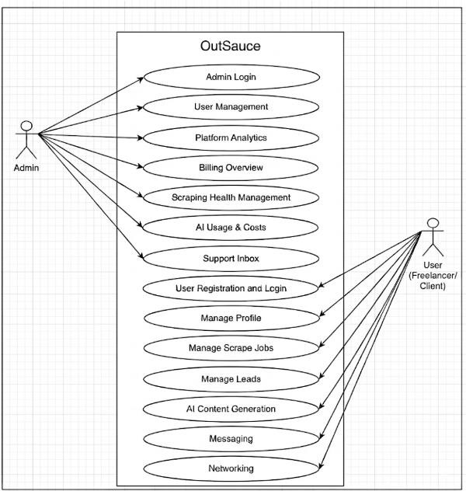
Figure 3.1 Use Case Diagram

Detailed Use Case
Table 3.1 UC-1: Admin Login: This use case describes secure authentication for admin access to the system dashboard.
Field | Description
Use Case ID | UC-1
Use Case Name | Admin Login
Actor(s) | Admin
Description/Goal | Allow admin to securely access the admin panel
Preconditions | Admin account exists
Postconditions | Admin is authenticated and redirected to admin dashboard
Main Flow | - Admin opens login page  - Enters credentials  - System validates  - Access granted
Alternate Flow | Invalid credentials → show error
Business Rules | Admin authentication must be secure
Dependencies | None
Priority | High

Table 3.2 UC-2: User Management: This use case defines how the admin manages user accounts and their activities.

Field | Description
Use Case ID | UC-2
Use Case Name | User Management
Actor(s) | Admin
Description/Goal | Admin manages user accounts and activities
Preconditions | Admin must be logged in
Postconditions | User data updated or actions applied
Main Flow | - Admin views users list  - Selects user  - Performs action (update/suspend/delete)  - System saves changes
Alternate Flow | Invalid action → show error
Business Rules | Admin has full control over user accounts
Dependencies | UC-1
Priority | High

Table 3.3 UC-3: Platform Analytics: This use case explains how the admin views system performance and usage analytics.

Field | Description
Use Case ID | UC-3
Use Case Name | Platform Analytics
Actor(s) | Admin
Description/Goal | Admin monitors system performance and usage metrics
Preconditions | Admin must be logged in
Postconditions | Analytics data displayed
Main Flow | - Admin opens analytics dashboard  - System fetches data  - Displays reports and charts
Alternate Flow | Data unavailable → show message
Business Rules | Data must be accurate and updated
Dependencies | UC-1
Priority | Medium

Table 3.4 UC-4: Billing Overview: This use case covers monitoring of subscriptions, payments, and
revenue data by the admin.

Field | Description
Use Case ID | UC-4
Use Case Name | Billing Overview
Actor(s) | Admin
Description/Goal | Admin monitors subscriptions and payments
Preconditions | Admin must be logged in
Postconditions | Billing data displayed
Main Flow | - Admin opens billing section  - Views subscriptions and revenue  - Reviews payment records
Alternate Flow | No data → show message
Business Rules | Financial data must be secure
Dependencies | UC-1
Priority | High

Table 3.5 UC-5: Scraping Health Management: This use case describes monitoring and managing
scraping jobs and system health.

Field | Description
Use Case ID | UC-5
Use Case Name | Scraping Health Management
Actor(s) | Admin
Description/Goal | Admin monitors scraping jobs and system health
Preconditions | Admin must be logged in
Postconditions | Scraping status monitored and issues identified
Main Flow | - Admin views scraping dashboard  - Checks job status  - Identifies failures  - Takes corrective action
Alternate Flow | System error → show alert
Business Rules | Scraping must comply with platform policies
Dependencies | UC-1
Priority | High

Table 3.6 UC-6: AI Usage and Costs: This use case outlines tracking of AI usage metrics and opera-
tional cost analysis.

Field | Description
Use Case ID | UC-6
Use Case Name | AI Usage and Costs
Actor(s) | Admin
Description/Goal | Admin monitors AI usage and operational costs
Preconditions | Admin must be logged in
Postconditions | AI usage data displayed
Main Flow | - Admin opens AI usage dashboard  - Views requests and token usage  - Monitors cost trends
Alternate Flow | Data unavailable → show message
Business Rules | Usage tracking must be accurate
Dependencies | UC-1
Priority | Medium

Table 3.7 UC-7: Support Inbox: This use case details how the admin handles user queries, complaints,
and support tickets.

Field | Description
Use Case ID | UC-7
Use Case Name | Support Inbox
Actor(s) | Admin
Description/Goal | Admin manages user complaints and support requests
Preconditions | Admin must be logged in
Postconditions | Queries resolved or responded
Main Flow | - Admin opens support inbox  - Views tickets/messages  - Responds or resolves issue
Alternate Flow | No tickets → show empty state
Business Rules | Responses must be timely and professional
Dependencies | UC-1
Priority | Medium

Table 3.8 UC-8: User Registration: This use case describes the process of new users creating accounts
on the platform.

Field | Description
Use Case ID | UC-8
Use Case Name | User Registration
Actor(s) | Freelancer, Client
Description/Goal | Allow new users to create an account on the platform
Preconditions | User has internet access and a valid email
Postconditions | User account is successfully created
Main Flow | - User opens signup page  - Enters details (email, password, etc.)  - System validates input  - Account is created
Alternate Flow | Email already exists → show error Invalid data → prompt correction
Business Rules | Password must meet security requirements
Dependencies | None
Priority | High

Table 3.9 UC-9: User Login: This use case explains secure authentication for registered users.

Field | Description
Use Case ID | UC-9
Use Case Name | User Login
Actor(s) | Freelancer, Client
Description/Goal | Allow registered users to log in securely
Preconditions | User must have a registered account
Postconditions | User is authenticated and redirected to dashboard
Main Flow | - User opens login page  - Enters credentials  - System validates  - Access granted
Alternate Flow | Invalid credentials → show error
Business Rules | Secure authentication must be enforced
Dependencies | UC-8
Priority | High

Table 3.10 UC-10: Manage Profile: This use case covers creation, viewing, and updating of user profile information.
Field | Description
Use Case ID | UC-10
Use Case Name | Manage Profile
Actor(s) | Freelancer, Client
Description/Goal | Users can create, update, and view their profile
Preconditions | User must be logged in
Postconditions | Profile is updated successfully
Main Flow | - User opens profile  - Edits details  - System validates  - Saves changes
Alternate Flow | Missing fields → show error
Business Rules | Profile fields must be valid and complete
Dependencies | UC-9
Priority | High

Table 3.11 UC-11: Manage Scrape Jobs: This use case describes configuring and executing scraping
jobs to collect external data.

Field | Description
Use Case ID | UC-11
Use Case Name | Manage Scrape Jobs
Actor(s) | Freelancer, Client
Description/Goal | Users configure and run scraping jobs to collect data from  external platforms
Preconditions | User must be logged in
Postconditions | Scrape job executed and results stored
Main Flow | - Create scrape job  - Define filters (keywords, location)  - System triggers scraping (n8n)  - Store results
Alternate Flow | No results → show message Scrape failure → retry option
Business Rules | Scrape must follow platform limits and policies
Dependencies | UC-9
Priority | High

Table 3.12 UC-12: Manage Leads: This use case explains organizing and managing saved opportuni-
ties as structured leads.

Field | Description
Use Case ID | UC-12
Use Case Name | Manage Leads
Actor(s) | Freelancer, Client
Description/Goal | Users save and organize opportunities as leads
Preconditions | Scrape results available
Postconditions | Leads stored and categorized
Main Flow | - Select scraped result  - Save as lead  - Add tag/folder  - Update status
Alternate Flow | Duplicate lead → prevent saving
Business Rules | Each lead must be unique
Dependencies | UC-11
Priority | High

Table 3.13 UC-13: AI Content Generation: This use case covers generation of professional content using AI services.

Field | Description
Use Case ID | UC-13
Use Case Name | AI Content Generation
Actor(s) | Freelancer, Client
Description/Goal | Generate professional content such as bio, resume, cover  letter, gig description
Preconditions | User must be logged in
Postconditions | AI-generated content displayed
Main Flow | - Select content type  - Enter details  - System calls Anthropic API  - Output displayed
Alternate Flow | API failure → error message
Business Rules | Content must be relevant and safe
Dependencies | UC-9
Priority | Medium

Table 3.14 UC-14: Messaging: This use case describes real-time communication between users with-
in the platform.

Field | Description
Use Case ID | UC-14
Use Case Name | Messaging
Actor(s) | Freelancer, Client
Description/Goal | Enable real-time communication between users
Preconditions | User must be logged in
Postconditions | Message stored and delivered
Main Flow | - Open chat  - Select user  - Send message  - Deliver in real-time
Alternate Flow | User offline → message stored
Business Rules | Messages must be secure and stored
Dependencies | UC-9
Priority | Medium

Table 3.15 UC-15: Networking: This use case explains how users discover and connect with each other through the system.

Field | Description
Use Case ID | UC-7
Use Case Name | Networking
Actor(s) | Freelancer, Client
Description/Goal | Discover and connect with other users
Preconditions | User must be logged in
Postconditions | Connection request sent/received
Main Flow | - Browse users  - Send request  - Accept/reject connection
Alternate Flow | Request ignored → remains pending
Business Rules | Users can only connect after approval
Dependencies | UC-9
Priority | Medium

Functional Requirements

OutSauce is designed as a modular, AI-powered freelancing platform that integrates cross- platform data scraping, lead management, networking, and productivity tools. The system must meet the following functional requirements:

User Registration and Authentication

  - Users must be able to register and create accounts securely.
  - The system must support login, logout, and password management.
  - Role-based access control must be implemented for Freelancers, Clients, and Admin.

Profile Management

  - Users can create, update, and manage their professional profiles.
  - The system must allow users to add skills, experience, interests, and portfolio links.
  - Users can control profile visibility (discoverable/non-discoverable).

Scrape Job Management

  - Users can create and configure scraping jobs to collect data from external platforms.
  - The system must support filters such as keywords, location, and platform selection.
  - Scraping jobs must be executed through automation workflows (e.g., n8n).
  - Users can view job status, results, and error messages.

Scrape Results Handling

  - The system must store and display scraped job listings and freelancer data.
  - Users can view detailed information such as title, company, and location.
  - Results must be searchable and filterable.

Lead Management

  - Users can save scraped results as leads.
  - The system must allow organizing leads using folders, tags, and status updates.
  - Duplicate leads should be prevented.
  - Users can track and manage lead progress.

AI Content Generation

  - Users can generate professional content such as resumes, bios, proposals, and gig descriptions.
  - The system must integrate with an AI API (e.g., Anthropic).
  - Users provide input, and the system generates relevant and safe content.

Messaging System
  - The platform must support real-time messaging between users.
  - Users can send, receive, and store messages securely.
  - Messages must support delivery status (sent, delivered).

Networking

  - Users can discover other professionals on the platform.
  - The system must allow sending, accepting, or rejecting connection requests.
  - Users can build and manage their professional network.

Conversations Management

  - The system must support multi-user conversations.
  - Users can participate in multiple conversations simultaneously.
  - Conversation history must be stored and accessible.

Subscription Management

  - The system must provide multiple subscription plans (Free, Starter, Pro, Enterprise).
  - Users can view, upgrade, or manage their subscription plans.
  - Subscription status must control feature access.

Usage Tracking

  - The system must track user activity such as scraping jobs, leads created, and AI usage.
  - Usage data must be used for analytics and billing enforcement.

Admin Dashboard

  - Admin must have access to a centralized dashboard.
  - The system must display platform metrics such as users, activity, and engagement.

Non-Functional Requirements
The following non-functional requirements define the quality attributes and constraints of the OutSauce system. These ensure that the system performs efficiently, securely, and reliably while providing a good user experience.
Table 3.16 Non Functional Requirements: This table summarizes the System quality requirements of OutSauce, including usability, performance, reliability, security, maintainability and availability.
NFR ID | Category | Requirement
NFR-1 | Usability | The system shall provide an intuitive and user-friendly interface for easy navigation
NFR-2 | Performance | The system shall respond to user actions within acceptable time limits under normal conditions
NFR-3 | Reliability | The system shall operate consistently with minimal failures
NFR-4 | Security | The system shall ensure secure handling of user data and authentication
NFR-5 | Scalability | The system shall support increased users and data without performance degradation
NFR-6 | Maintainability | The system shall be easy to maintain and update
NFR-7 | Availability | The system shall be accessible to users most of the time with minimal downtime

NFR-1: Usability
- The system shall allow users to easily navigate features such as profile management, scraping jobs, leads, messaging, and networking.
- The system shall provide clear instructions, labels, and tooltips to guide users.
- The system shall support responsive design for desktop, tablet, and mobile devices.
- Error messages shall be clear and help users correct mistakes.

NFR-2: Performance
- The system shall load most pages within 3–5 seconds under normal internet conditions.
- Scraping results shall be displayed within a reasonable time depending on external platform response.
- The system shall support multiple users without significant slowdown.
- Background processes (e.g., scraping) shall not interrupt active user sessions.

NFR-3: Reliability
- The system shall maintain high uptime (around 99%) excluding maintenance.
- The system shall handle temporary failures gracefully without crashing.
- Data shall be saved properly to prevent loss during failures.
- Regular system monitoring shall detect and handle errors.

NFR-4: Security

- User passwords shall be securely hashed before storage.
- All communication between client and server shall use HTTPS/SSL.
- Only authenticated users shall access system features.
- The system shall handle invalid login attempts securely.

NFR-5: Scalability
- The system shall handle increasing numbers of users and leads.
- The architecture shall support adding new features without major redesign.

- The system shall allow scaling of resources (server, database) when needed.

NFR-6: Maintainability
- The system shall follow modular coding practices.
- Code shall be documented for easy understanding.
- Errors shall be logged for debugging purposes.
- Updates and fixes shall be deployable with minimal disruption.

NFR-7: Availability
- The system shall be available to users most of the time (24/7 preferred).
- Maintenance downtime shall be minimal and planned.
- The system shall recover quickly after failures.

Chapter 4 Design and Architecture

Design And Architecture
In this section, we explore the architectural design and system models that provide a comprehensive understanding of the OutSauce platform. These models illustrate how different components of the system interact, how data flows across layers, and how modular design principles are applied to ensure scalability, maintainability, and extensibility. The architecture is designed to support a multi-functional SaaS platform that integrates scraping, lead management, networking, messaging, and AI-powered content generation within a unified environment.

System Architecture
OutSauce adopts a structured Three-Tier Modular Architecture, which separates the system into Presentation Layer, Business Logic Layer, and Data Access Layer. This architectural approach ensures scalability, maintainability, and a clear separation of concerns.

In addition, an Integration and Automation Layer is included to handle external services such as scraping and workflow automation. Each module is designed independently, allowing future enhancements without affecting the overall system.

Client Layer (Presentation Layer)

This layer represents the user-facing interface accessible through modern web browsers. It is developed using Next.js (App Router) with React, styled using Tailwind CSS and ShadCN UI [16].

Key Interfaces

  - Authentication (Login/Signup)
  - User Dashboard
  - Profile Management
  - Scrape Job Configuration
  - Lead Management Dashboard
  - Messaging Interface
  - Networking Module

  - AI Content Generation Tools

Responsibilities

  - Rendering responsive and interactive user interfaces
  - Capturing user inputs and actions
  - Communicating with backend APIs via HTTP requests
  - Handling real-time updates (e.g., messaging, scrape status) using Supabase Realtime
  - Managing client-side state and user sessions

Application Layer (Business Logic Layer)

This layer forms the core processing unit of the system and is implemented using NestJS [3]. It handles all application logic, processes client requests, and enforces business rules.

  - API Gateway (REST Endpoints): Entry point for all client-server communication
  - Authentication & Authorization: Managed using Supabase Auth and guarded via secure middleware
  - Modular Services Architecture: Each feature is implemented as an independent module

Business Modules Include

  - Authentication Module
  - Profile Management Module
  - Scrape Jobs Module
  - Lead Management Module
  - Messaging Module
  - Networking Module
  - AI Content Generation Module
  - Billing & Subscription Module

Responsibilities

  - Processing user requests and executing business logic

  - Managing workflows such as scraping jobs and lead pipelines
  - Enforcing subscription limits and access control
  - Integrating AI services for content generation
  - Handling real-time communication and messaging logic
  - Coordinating with external services through APIs

Data Layer (Data Access Layer)

This layer is responsible for persistent data storage and retrieval. OutSauce uses Supabase (PostgreSQL) as its primary database system.

Stored Data Includes

  - User accounts and profiles
  - Scrape jobs and results
  - Leads, folders, and tags
  - Messages and conversations
  - Network connections
  - Subscription and usage data
  - AI-generated content history

Key Technologies

  - Supabase PostgreSQL (Relational Database)
  - Supabase Realtime (WebSocket-based updates)
  - Row-Level Security (RLS) for data protection

Responsibilities

  - Performing CRUD operations
  - Maintaining data integrity and consistency
  - Enforcing security policies (RLS)
  - Supporting real-time data synchronization
  - Managing relationships between system entities

Integration and External Services Layer

To enhance functionality and reduce development overhead, OutSauce integrates several third-party services through a dedicated integration layer.

External Services Include

  - n8n: Handles scraping workflows and automation via webhooks
  - OpenAI API: Provides AI-powered content generation (bios, resumes, cover letters, etc.)
  - Stripe: Manages subscription billing and payment processing
  - Supabase Services: Provides authentication, database, and real-time features

Responsibilities

  - Executing automated scraping workflows
  - Processing and transforming external data
  - Enabling AI-based content generation
  - Managing subscription payments and billing cycles
  - Triggering background jobs and scheduled tasks
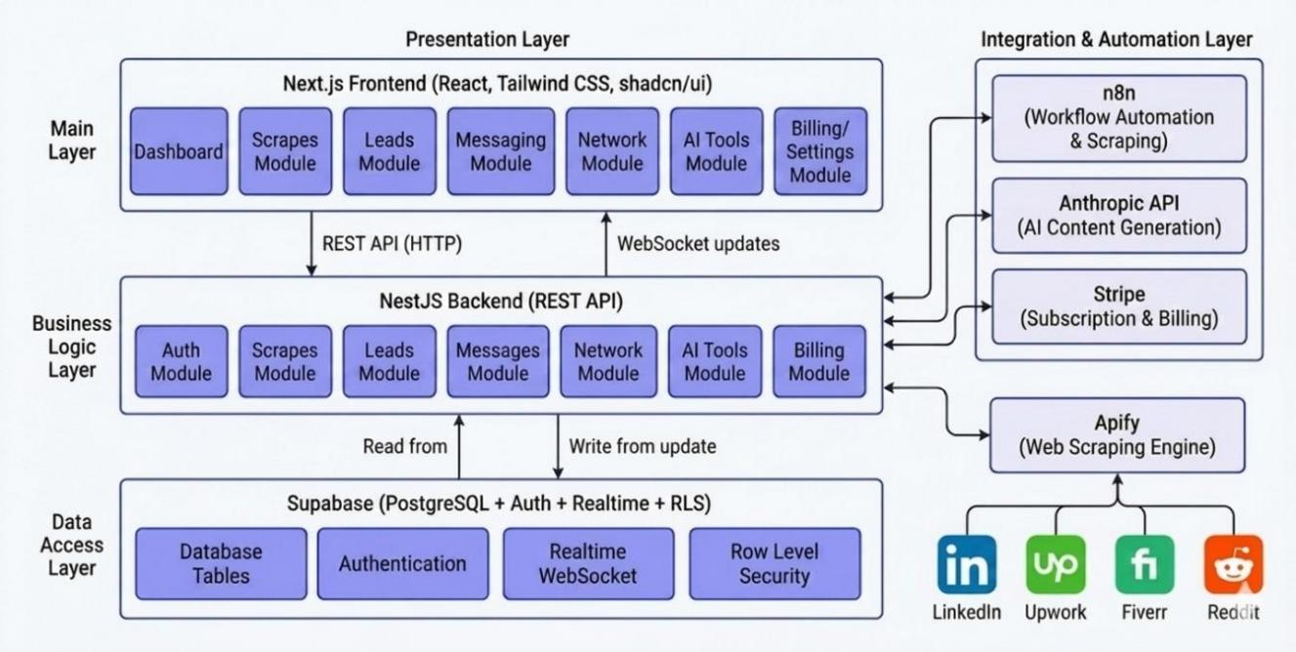

Figure 4.1 System Architecture Design

Data Representation
The data model for OutSauce is designed to support a scalable SaaS architecture, ensuring secure data isolation between users while maintaining strong relational integrity across multiple functional domains such as scraping, lead management, networking, messaging, and AI content generation. The system utilizes Supabase PostgreSQL as its core database, enabling structured storage, real-time synchronization, and secure access through Row-Level Security policies.

The core entities and their relationships are defined as follows:

- Profile (User Root): The primary entity representing a system user, including job seekers, freelancers, and employers. It stores personal and professional details such as skills, interests, user type, and discoverability settings. It acts as the parent entity for most system data and maintains relationships with scrape jobs, leads, connections, messages, subscriptions, and AI generations.
- Scrape Job: This entity represents a configured scraping task initiated by a user. It includes parameters such as keywords, platform sources, filters, and execution status (pending, running, completed, or failed). Each scrape job has a One-to-Many relationship with Scrape Results.
- Scrape Result: Represents individual opportunities retrieved from external platforms such as LinkedIn, Upwork, Fiverr, and Reddit. Each result is linked to a specific scrape job and can be converted into a lead. This entity stores details such as title, description, source, and metadata.
- Lead: This entity represents saved opportunities that users want to track. Each lead is linked to a profile and optionally associated with a folder. It stores attributes such as status (New, Contacted, In Progress, Closed, Archived), notes, and relevant details about the opportunity.
- Lead Folder: Used to organize leads into structured categories. Each folder belongs to a user and has a One-to-Many relationship with leads, allowing users to group opportunities efficiently.

- Tag: Represents custom labels created by users to categorize leads. Tags are linked to leads through a many-to-many relationship using an associative entity (Lead Tags), enabling flexible filtering and organization.
- Connection: This entity represents networking relationships between users. It stores sender and receiver information along with the connection status (pending, accepted, rejected), enabling professional networking features.
- Conversation: Represents a communication session between two or more users. It acts as a container for messages and maintains relationships with conversation participants.
- Message: Represents individual messages exchanged between users. Each message is linked to a conversation and stores content, timestamps, and delivery status (sent, delivered, read), providing a complete communication history.
- Subscription: This entity manages user subscription plans such as Free, Starter, Pro, and Enterprise. It is linked to external payment systems and maintains a One-to-One relationship with the user profile.
- Usage: Tracks resource consumption for each user, including scraping jobs, leads, and AI generations. It ensures enforcement of plan limits based on the user’s subscription.
- AI Generation: Stores records of content generated through AI services, including input parameters and generated outputs. This entity allows users to revisit previously generated content and maintains a history of AI interactions.

Level 0 DFD
This Data Flow Diagram (DFD) Level 0, also known as the Context Diagram, provides a high-level overview of the OutSauce platform and its interaction with external entities.

At the center is the OutSauce System, represented as a single process (Node 0), which encapsulates all functionalities including scraping, lead management, networking, messaging, and AI content generation. Surrounding this central process are the external entities that interact with the system by providing inputs and receiving outputs.

The interactions are described as follows:

      - User (Job Seeker / Freelancer / Employer): This entity represents the primary users of the system. Users provide inputs such as authentication data, scrape configurations, lead management actions, networking requests, and messages. In return, the system provides outputs including dashboards, scraped opportunities, organized leads, connection suggestions, real-time messages, and AI-generated content.

      - External Platforms (LinkedIn, Upwork, Fiverr, Reddit): These platforms act as data sources for job and freelance opportunities. The OutSauce system sends scraping requests through automation workflows and receives structured opportunity data as scrape results.
      - n8n (Automation Engine): This external service handles workflow automation and scraping execution. The system sends scrape job configurations to n8n via webhooks, and n8n returns processed data back to the system through API endpoints.
      - Anthropic Service: This entity provides AI capabilities for content generation. The OutSauce system sends prompts and user inputs to the AI service and receives generated content such as bios, resumes, cover letters, and descriptions.
      - Stripe: This external payment gateway handles subscription billing and transactions. The system sends payment requests and subscription details to Stripe [7], which returns transaction status and billing updates.
      - Supabase (Authentication & Realtime Services): This service manages authentication, session handling, and real-time communication. The system exchanges authentication tokens, user session data, and real-time event updates for messaging and scraping status.

In essence, the Level 0 DFD illustrates how the OutSauce system interacts with users and external services to perform its core functionalities.

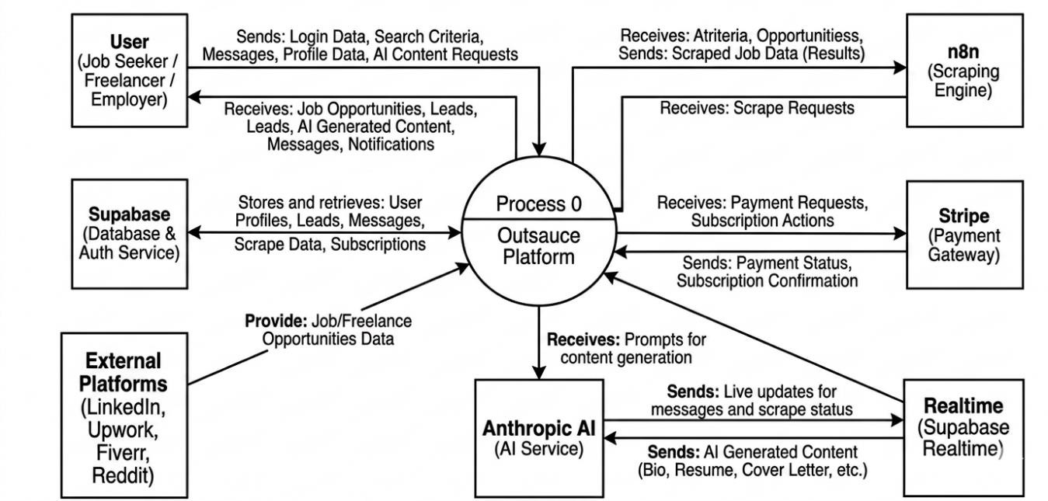

Figure 4.2 Level 0 DFD

Level 1 DFD
This Data Flow Diagram (DFD) Level 1 provides a detailed decomposition of the OutSauce system, expanding upon the high-level abstraction presented in Level 0. It illustrates how the major functional modules interact with each other, external services, and the central database to perform core operations.

At the center of the system lies the primary data repository:

Central Database (D1 - Supabase PostgreSQL)

This serves as the core storage layer of the system, maintaining all structured data including Profiles, Scrape Jobs, Scrape Results, Leads, Messages, Connections, Subscriptions, Usage, and AI Generations. All processes read from and write to this database while enforcing Row Level Security for data isolation.

The system is composed of the following key processes:

Manage Authentication & Profiles

This process handles user authentication, session management, and profile operations. It receives login credentials and registration data from users via Supabase Auth. Upon successful authentication, it generates validated session tokens that allow secure access to other modules. It also creates and updates user profiles, storing relevant data in the Profiles table within D1.

2.0 Manage Scraping Workflow

This process is responsible for handling multi-platform scraping operations. It receives scrape configurations (keywords, filters, platforms) from users and sends these requests to the n8n automation engine via webhooks. The system then receives structured scrape results from n8n and stores them in the Scrape Jobs and Scrape Results tables in D1. It also interacts with the realtime service to provide live status updates.

3.0 Manage Leads & Organization

This process manages the lifecycle of leads generated from scraping results. It receives user actions such as saving leads, updating statuses, assigning folders, adding tags, and writing notes. It reads and writes data to Leads, Lead Folders, Tags, and Lead Tags tables in D1. It also supports exporting lead data in formats such as CSV and JSON.

Manage Networking & Messaging

This process facilitates user interaction and communication. It handles connection requests, acceptance/rejection of connections, and user discovery based on skills and interests. It also manages real-time messaging between users, storing conversations and messages in D1 while utilizing Supabase Realtime for instant communication updates.

5.0 Manage AI Content Generation

This process provides AI-powered content generation capabilities. It receives prompts and content requests (such as bio, resume, or cover letter generation) from users and sends them to the external Anthropics service. The generated responses are returned to the system and stored in the AI Generations table in D1 for future reference.

6.0 Manage Billing & Subscriptions

This process handles subscription plans and payment workflows. It sends payment requests and subscription actions to Stripe [7] and receives transaction confirmations. It updates the Subscriptions and Usage tables in D1 to enforce plan limits and track resource consumption.

This Level 1 DFD clearly demonstrates how OutSauce integrates multiple subsystems and external services to deliver a unified platform for opportunity aggregation, lead management, networking, and AI-driven assistance.
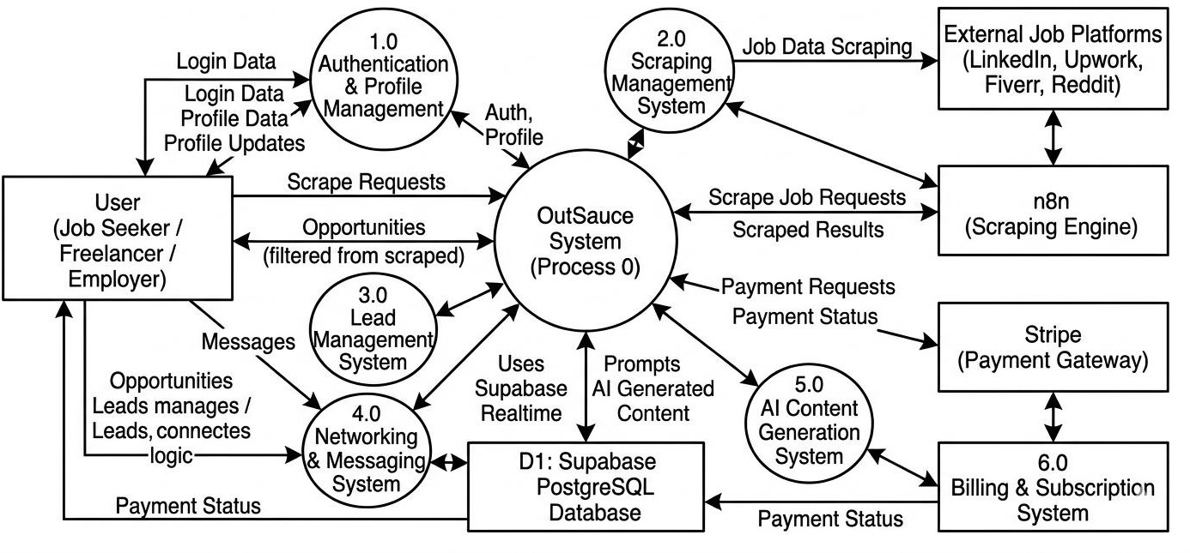
Figure 4.3 Level 1 DFD

Level 2 DFD

Drill-down of Process 2.0: Manage Scraping Workflow

This diagram illustrates the internal workflow of the scraping process, from user input to data storage.

- The process begins when the user submits scrape criteria, which is handled by 2.1 Scrape Configuration. This step validates user input and prepares the request.
- The validated configuration flows to 2.2 Trigger Scraping Engine, where the system sends a webhook request to the n8n automation engine.
- The n8n service processes the request and returns structured job data, which is received by 2.3 Receive Scrape Results.
- The results are passed to 2.4 Process and Normalize Data, where the system formats and standardizes the incoming data.
- Finally, 2.5 Store Results saves the processed data into the Scrape Jobs and Scrape Results tables in D1. Real-time updates are simultaneously pushed to the user interface via Supabase Realtime.
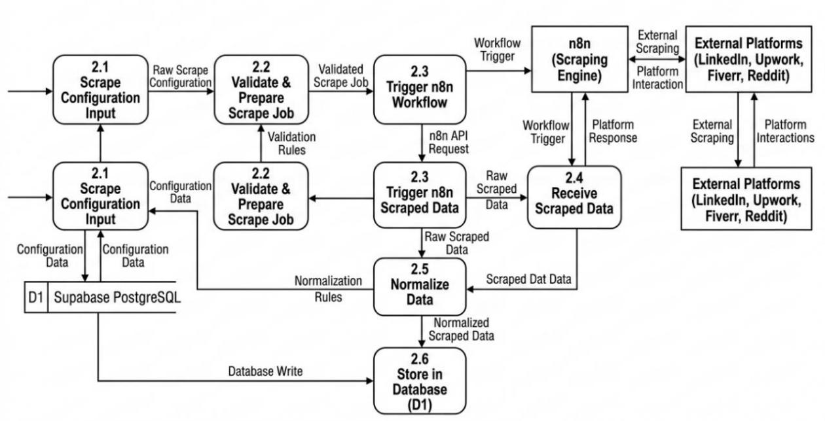

Figure 4.4 DFD Level 2 Manage Scraping Workflow

Drill-down of Process 3.0: Manage Leads and Organization

This diagram explains how users manage and organize leads within the system.

- User actions are received by 3.1 Save or Update Lead, which stores new leads or updates existing ones in the Leads table.
- The data flows to 3.2 Manage Lead Status, where users update the pipeline stage (New, Contacted, In Progress, Closed, Archived).
- 3.3 Folder Management allows users to create, update, and assign folders to leads, interacting with the Lead Folders table.
- 3.4 Tag Management handles the creation and assignment of tags, maintaining relationships through the Lead Tags table. 3.5 Export Leads retrieves structured lead data from D1 and converts it into CSV or JSON format for download.
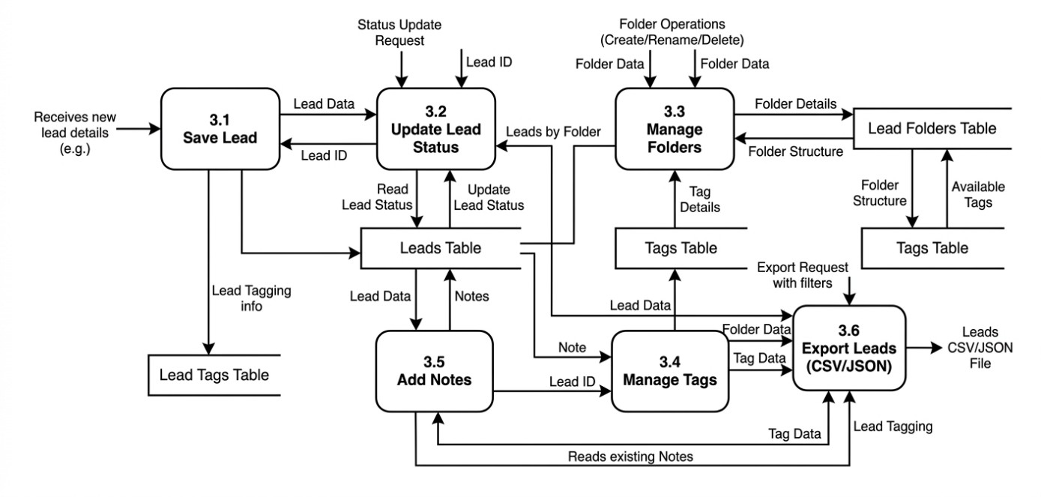

Figure 4.5 DFD Level 2 Manage Leads and Organization

Drill-down of Process 4.0: Manage Networking and Messaging

This diagram represents how user connections and communication are handled.

- 4.1 User Discovery retrieves matching profiles from D1 based on shared skills and interests.
- 4.2 Connection Management processes connection requests, storing their status (pending, accepted, rejected) in the Connections table.
- 4.3 Conversation Management creates or retrieves conversations between users.
- 4.4 Message Processing handles sending and receiving messages, storing them in the Messages table.
- 4.5 Real-Time Delivery uses Supabase Realtime to instantly deliver messages and update read statuses.
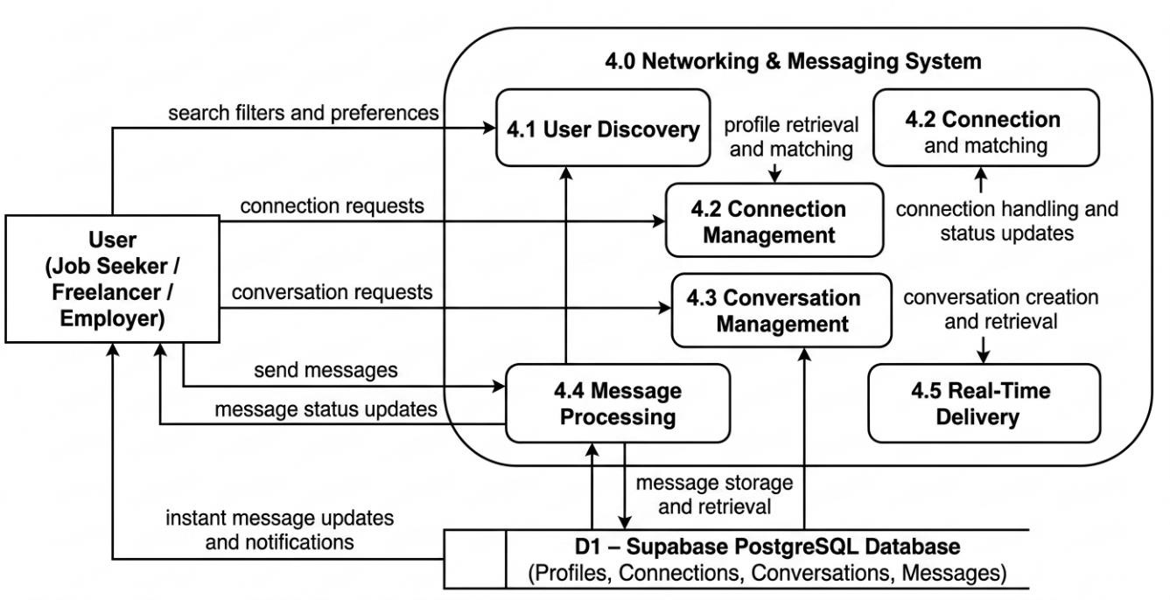

Figure 4.6 DFD Level 2 Manage Networking and Messaging

Drill-down of Process 5.0: Manage AI Content Generation

This diagram explains the AI interaction workflow.

- User input is received by 5.1 Prompt Preparation, where the system structures the request.
- The prepared prompt is sent to 5.2 AI Interaction, which communicates with the Anthropics service.
- The generated content flows to 5.3 Response Processing, where it is validated and formatted.
- Finally, 5.4 Store AI Output saves the generated content in the AI Generations table in D1 for future retrieval.
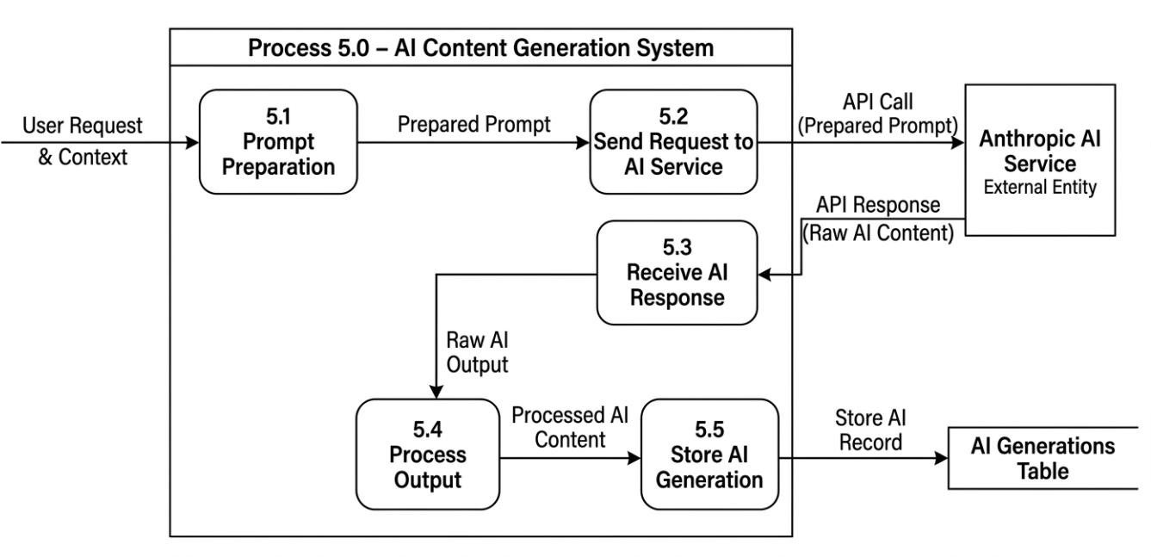

Figure 4.7 DFD Level 2 Manage AI Content Generation

Data Dictionary
The OutSauce schema is composed of multiple interrelated entities, each representing a specific functional domain of the platform.
Table 4.1 Profile Entity: Stores user profile information including personal details, skills, preferences, and account settings.

Field Name | Type | Constraints | Description
id | UUID | Primary Key, FK → auth.users(id) | Unique user identifier
email | String | Not Null | User email
full_name | String | Nullable | User full name
avatar_url | String | Nullable | Profile image URL
user_type | Enum | Default: job_seeker | Type of user
headline | String | Nullable | Short professional title
bio | String | Nullable | User description
interests | String [] | Default: {} | List of interests
skills | String [] | Default: {} | List of skills
location | String | Nullable | User location
linkedin_url | String | Nullable | LinkedIn profile
website_url | String | Nullable | Personal website
is_discoverable | Boolean | Default: true | Visibility status
onboarding_completed | Boolean | Default: false | Profile completion  status
created_at | DateTime | Default: now () | Record creation time
updated_at | DateTime | Auto-updated | Last update time

Table 4.2 Scrape Jobs Entity: Manages user-created scraping tasks including sources, status, and exe- cution details.

Field Name | Type | Constraints | Description
id | UUID | Primary Key | Unique job ID
user_id | UUID | FK → profiles(id) | Owner of job
name | String | Not Null | Job name
sources | Enum [] | Not Null | Platforms to scrape
criteria | JSONB | Default: {} | Filters/criteria
status | Enum | Default: pending | Job status
n8n_execution_id | String | Nullable | Workflow ID
result_count | Integer | Default: 0 | Results count
error_message | String | Nullable | Error details
started_at | DateTime | Nullable | Start time
completed_at | DateTime | Nullable | End time
created_at | DateTime | Default: now () | Created time
updated_at | DateTime | Auto-updated | Updated time

Table 4.3 Scrape Results Entity: Stores extracted data from scraping jobs such as job listings, metadata, and source details.

Field Name | Type | Constraints | Description
id | UUID | Primary Key | Unique result ID
scrape_job_id | UUID | FK → scrape_jobs(id) | Related job
user_id | UUID | FK → profiles(id) | Owner
source | Enum | Not Null | Source platform
source_url | String | Nullable | Original link
title | String | Not Null | Job title
description | String | Nullable | Job details
company | String | Nullable | Company name
location | String | Nullable | Job location
salary_range | String | Nullable | Salary text
salary_min | Integer | Nullable | Min salary
salary_max | Integer | Nullable | Max salary
metadata | JSONB | Default: {} | Extra data
scraped_at | DateTime | Default: now () | Scraped time
created_at | DateTime | Default: now () | Created time

Table 4.4 Leads Entity: Maintains organized and categorized opportunities saved from scraped results for user management.

Field Name | Type | Constraints | Description
id | UUID | Primary Key | Lead ID
user_id | UUID | FK → profiles(id) | Owner
scrape_result_id | UUID | FK → scrape_results(id) | Source data
folder_id | UUID | FK → lead_folders(id) | Folder
source | Enum | Nullable | Platform
title | String | Not Null | Lead title
description | String | Nullable | Details
company | String | Nullable | Company
location | String | Nullable | Location
status | Enum | Default: new | Lead status
notes | String | Nullable | User notes
metadata | JSONB | Default: {} | Extra data
created_at | DateTime | Default: now () | Created
updated_at | DateTime | Auto-updated | Updated

Table 4.5 Lead Folders Entity: Organizes leads into user-defined folders for better categorization and management.

Field Name | Type | Constraints | Description
id | UUID | Primary Key | Folder ID
user_id | UUID | FK → profiles(id) | Owner
name | String | Not Null | Folder name
color | String | Default | UI color
created_at | DateTime | Default: now () | Created

Table 4.6 Tags Entity: Defines user-created labels for categorizing and filtering leads and data.

Field Name | Type | Constraints | Description
id | UUID | Primary Key | Tag ID
user_id | UUID | FK → profiles(id) | Owner
name | String | Not Null | Tag name
color | String | Default | Tag color
created_at | DateTime | Default: now () | Created

Table 4.7 Messages Entity: Stores chat messages exchanged between users within conversations.

Field Name | Type | Constraints | Description
id | UUID | Primary Key | Message ID
conversation_ id | UUID | FK → conversations(id) | Conversation
sender_id | UUID | FK → profiles(id) | Sender
content | String | Not Null | Message text
status | Enum | Default: sent | Message status
created_at | DateTime | Default: now () | Sent time

Table 4.8 Conversations Entity: Manages chat sessions between users with timestamps and metadata.

Field Name | Type | Constraints | Description
id | UUID | Primary Key | Conversation ID
created_at | DateTime | Default: now () | Created
updated_at | DateTime | Auto-updated | Updated

Table 4.9 Connections Entity: Handles user connection requests and relationship statuses within the platform.

Field Name | Type | Constraints | Description
id | UUID | Primary Key | Connection ID
requester_id | UUID | FK → profiles(id) | Sender
recipient_id | UUID | FK → profiles(id) | Receiver
status | String | Default: pending | Request status
message | String | Nullable | Optional message
created_at | DateTime | Default: now () | Created

Table 4.10 AI Generations Entity: Records AI-generated content such as resumes, bios, and outputs.

Field Name | Type | Constraints | Description
id | UUID | Primary Key | Record ID
user_id | UUID | FK → profiles(id) | Owner
tool_type | Enum | Not Null | Type (bio, resume, etc.)
input_data | JSONB | Not Null | Input
output_text | String | Not Null | Generated content
created_at | DateTime | Default: now () | Created

Table 4.11 Subscriptions Entity: Manages user subscription plans and plan-related details.

Field Name | Type | Constraints | Description
Id | UUID | Primary Key | Subscription ID
user_id | UUID | FK → profiles(id) | User
Plan | Enum | Default: free | Plan type
created_at | DateTime | Default: now () | Created

Table 4.12 Usage Entity: Tracks system usage metrics including AI, scraping, and lead generation ac-
tivity monitoring.

Field Name | Type | Constraints | Description
id | UUID | Primary Key | Usage ID
user_id | UUID | FK → profiles(id) | User
leads_used | Integer | Default: 0 | Leads usage
scrapes_used | Integer | Default: 0 | Scraping usage
ai_generations_used | Integer | Default: 0 | AI usage
created_at | DateTime | Default: now () | Created

Entity Relationship Diagram
The OutSauce database schema is designed using a relational structure in which entities are interconnected through well-defined relationships. These relationships ensure data consistency, scalability, and efficient access across core system modules such as authentication, scraping, lead management, messaging, networking, and AI content generation.

The key entity relationships in the system are described below:

User and Profile Relationship

Each authenticated user is associated with a single profile record. This represents a one-to-one relationship where the profiles table extends the Supabase auth.users entity. The relationship is enforced using a foreign key constraint with cascade delete behavior to ensure data integrity.

Profile and Scrape Jobs Relationship
A single user can create multiple scrape jobs to extract data from different platforms. This establishes a one-to-many relationship between Profile and Scrape Job entities.

Scrape Jobs and Scrape Results Relationship
Each scrape job generates multiple scrape results based on external platform data. This forms a one-to-many relationship where results are dependent on their parent scrape job.

Profile and Leads Relationship

A user can store multiple leads derived from scraped results. This represents a one- to-many relationship between Profile and Lead entities.

Leads and Lead Folders Relationship

Leads can optionally be organized into folders for better management. A folder can contain multiple leads, forming a one-to-many relationship between Lead Folder and Lead entities.

Leads and Tags Relationship

Leads can have multiple tags, and each tag can belong to multiple leads. This is a many-to-many relationship implemented through the Lead_Tags junction table.

Profile and Connections Relationship
Users can send and receive connection requests to establish professional networking relationships. This is a self-referential many-to-many relationship managed through the Connections table, where both sender and receiver reference user profiles.
      - Conversations and Messages Relationship

Each conversation can contain multiple messages, forming a one-to-many relationship. Every message belongs to a specific conversation and includes sender information, timestamps, and delivery status.

Conversation Participants Relationship

A conversation can include multiple users, and a user can participate in multiple conversations. This forms a many-to-many relationship implemented through the Conversation_Participants table.

Profile and AI Generations Relationship

Each user can generate multiple AI-powered content outputs such as resumes, bios, cover letters, and job descriptions. This represents a one-to-many relationship.

Profile and Subscriptions Relationship

Each user has one subscription record that defines their active plan (Free, Starter, Pro, Enterprise). This is a one-to-one relationship between Profile and Subscription.

Profile and Usage Tracking Relationship

User activity is tracked through usage records such as scrape executions, lead creations, and AI generations. This represents a one-to-many relationship over time for analytics and billing enforcement.

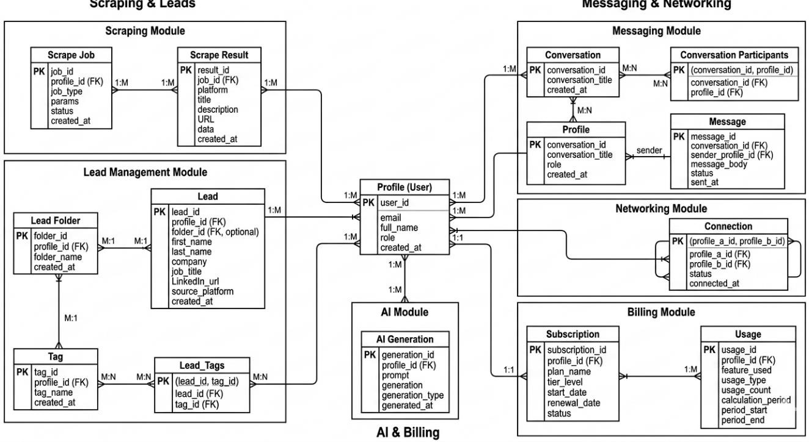

Figure 4.8 ER Diagram

Process Flow

A visual representation of the workflow is essential to understand the end-to-end functionality of the OutSauce platform. The activity diagram below illustrates the sequence of system operations, user interactions, and integrations across different modules.

The process flow diagram demonstrates the complete journey of a user from accessing the platform to generating leads, interacting with freelancers/clients, utilizing AI-powered tools, and analyzing performance metrics. It highlights how the system integrates authentication, data pipelines, AI processing, communication, and analytics into a unified workflow.

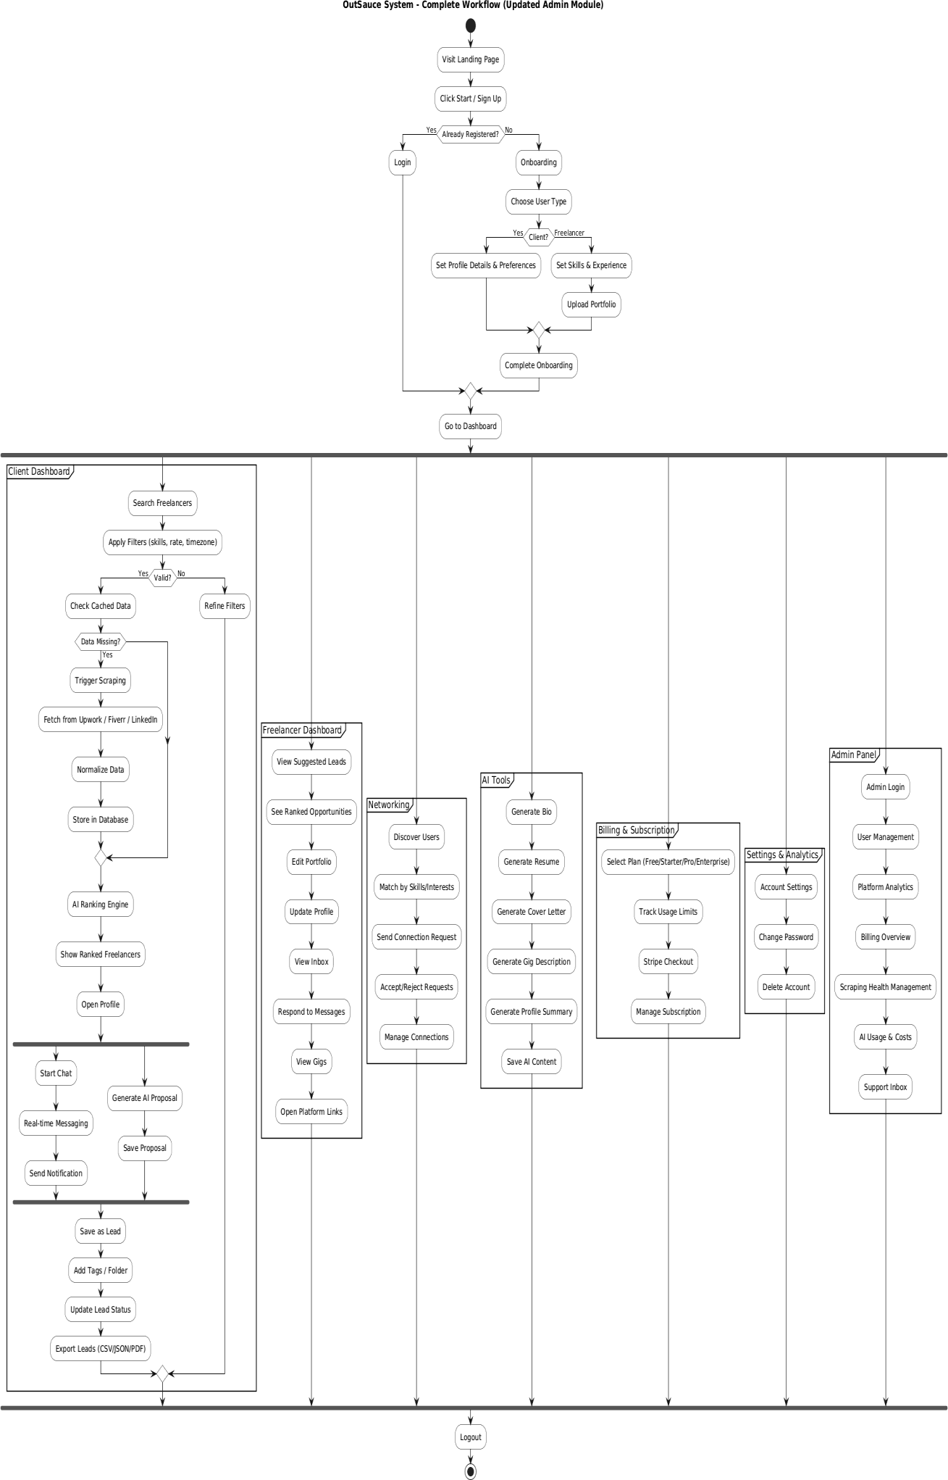

Figure 4.9 Process Flow Diagram

Landing Page → Registration & Login

  - The user starts by visiting the OutSauce landing page.
  - They click on Start / Sign Up to begin.
  - The system checks whether the user is already registered:
    - If registered → the user logs in.
    - If not registered → the user proceeds to onboarding.

After successful authentication, the user continues to the onboarding process.

Onboarding Process

The onboarding flow ensures that the user sets up their profile and preferences:

  - Users select their role (Client or Freelancer).
  - Clients set profile details and preferences.
  - Freelancers add skills, experience, and upload portfolios.
  - After completing onboarding, users are redirected to the dashboard.

This marks the start of the main system interaction.

Client Dashboard (Lead Generation Flow)

The client-side workflow focuses on finding and managing freelancers:

  - Search freelancers using filters (skills, rate, timezone).
  - System checks cached data:
- If data is missing → triggers n8n scraping workflows.
- Data is fetched from platforms like LinkedIn, Upwork, and Fiverr.
  - Data is normalized and stored in the database.
  - AI ranking engine processes and ranks freelancers.
  - Clients can:
- View ranked freelancers
- Open profiles
- Start chat (real-time messaging)
- Generate AI proposals

Leads can then be:

  - Saved
  - Tagged and organized into folders
  - Updated with statuses
  - Exported (CSV/JSON/PDF)

Freelancer Dashboard

Freelancers manage opportunities and profiles:

  - View suggested leads and ranked opportunities
  - Edit profile and upload work samples
  - Manage portfolio and gigs
  - Access inbox and respond to messages
  - Open external platform links

This module enables freelancers to actively engage with potential clients.

Networking Module

The networking feature allows users to build professional connections:

  - Discover users based on interests and skills
  - Match profiles intelligently
  - Send connection requests
  - Accept or reject requests
  - Manage connections

This enhances collaboration and platform engagement.

AI Tools Module

AI-powered tools assist users in content creation:

  - Generate bio

  - Generate resume
  - Generate cover letters
  - Generate gig descriptions
  - Generate profile summaries
  - Save generated content

This reduces manual effort and improves content quality.

Communication Module

The communication system supports real-time interaction:

  - Users can start chats instantly
  - Messaging is powered by Supabase Realtime
  - Notifications are sent for updates and responses

This ensures smooth and efficient communication between users.

Billing & Subscription Module

The platform supports multiple subscription plans:

  - Users select plans (Free, Starter, Pro, Enterprise)
  - Usage limits are tracked
  - Payments are processed via Stripe [7]
  - Subscription management (upgrade/downgrade) is available This aligns with the SaaS monetization model.

Settings & Analytics Module
Users can customize settings and track performance:

  - Account settings management
  - Change password and theme
  - Access analytics dashboard

  - View AI-driven market trends

This module provides insights into user activity and platform performance.

Admin Panel
The admin module controls system-level operations:

  - Manage users
  - View system metrics
  - Adjust platform settings
  - Configure scraping sources

This ensures smooth system governance and maintenance.

Logout

  - Users can securely log out at any time.
  - This marks the end of the session and completes the process flow.

Design Models

The following design models illustrate the high-level interaction flows within the OutSauce platform, demonstrating how frontend components, backend services, database systems, automation pipelines, and AI modules collaborate to deliver core functionalities.

These models provide a clear understanding of how users interact with the system and how data flows across different layers, including:

- User interface (Next.js frontend)
- Backend services (NestJS API)
- Database and authentication (Supabase)
- External integrations (n8n, Stripe, AI services)

They highlight the end-to-end processes involved in lead generation, freelancer discovery, communication, and content generation.

Sequence Diagrams
The sequence diagrams of OutSauce illustrate the dynamic interactions among users, the frontend interface, backend services (developed in NestJS), the database layer (Supabase), and external integrations (including n8n, AI services, and Stripe). These diagrams collectively describe the runtime behavior and communication flow across the system’s core modules.

User and Auth Module
This sequence diagram represents the authentication and user onboarding process.
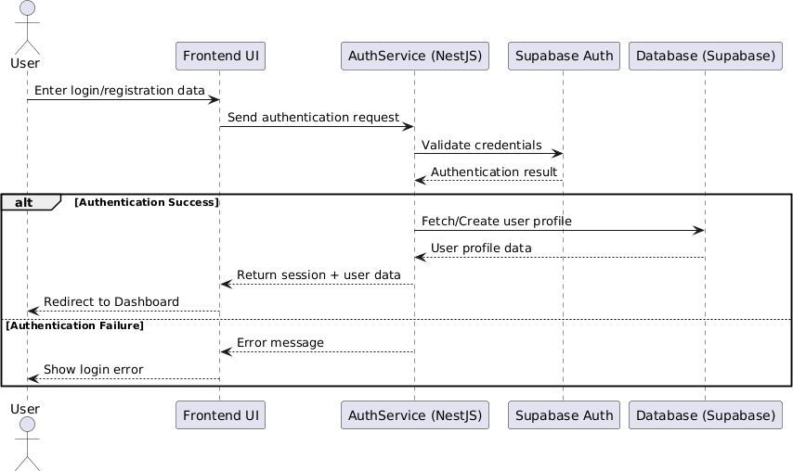

Figure 4.10 User and Auth Module

A user initiates a login or registration request via the user interface. The request is processed by the AuthService implemented in NestJS, which communicates with Supabase Auth for credential validation. Upon successful authentication, a secure session is generated. Subsequently, the system retrieves or creates the user profile and redirects the user to the application dashboard.

Data Aggregation (Scraping) Module
This sequence illustrates the automated data collection pipeline.
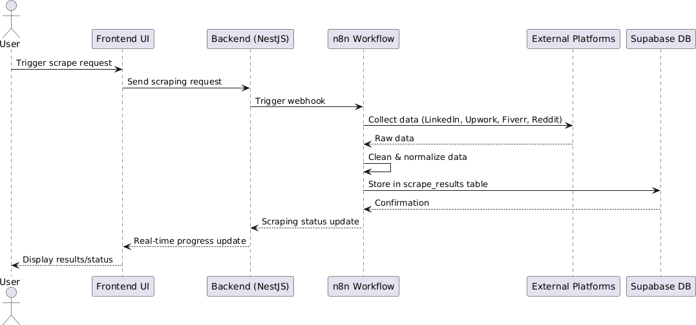

Figure 4.11 Data Aggregation Module

A user triggers a scraping request from the frontend. The backend processes this request and invokes an n8n [4] webhook workflow to initiate data aggregation. The workflow collects relevant data from external platforms such as LinkedIn, Upwork, Fiverr, and Reddit. The retrieved data is then cleaned, transformed, and normalized before being stored in the scrape_results table within Supabase. The system provides real-time progress updates to the frontend during execution.

Search and AI Ranking Module
This sequence describes the processing of search queries and intelligent ranking.
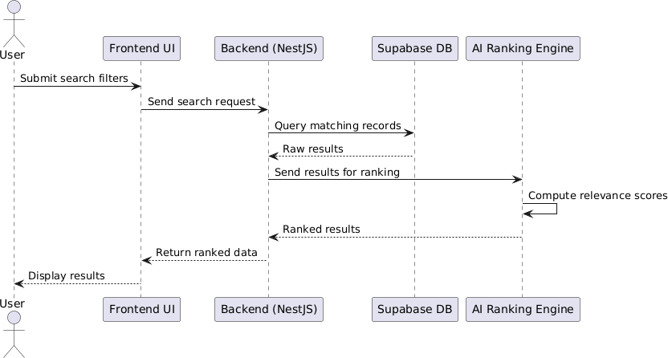

Figure 4.12 Search and AI Ranking Module

The client submits search parameters through the interface, which are validated and forwarded to the backend. The system retrieves matching records from Supabase and passes them to the AI Ranking Engine. This engine evaluates and assigns relevance scores to each record based on predefined and AI-driven criteria. The ranked results are then returned to the frontend for presentation.

AI Content Generation Module
This sequence outlines the AI-powered content generation workflow.
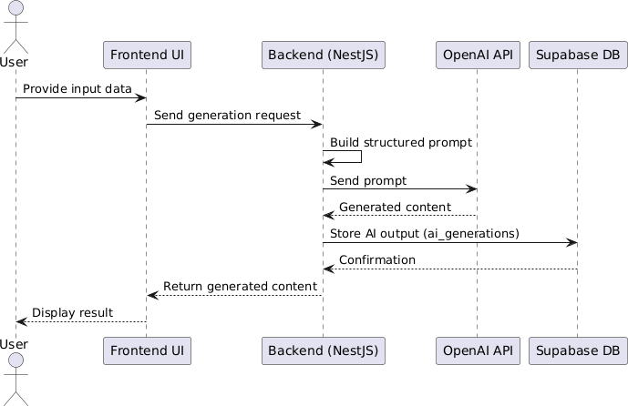

Figure 4.13 AI Content Generation Module

The user provides input data such as job details or profile information. The backend constructs a structured prompt and sends it to an external AI service (Anthropic API). The AI service generates the required content, such as proposals, resumes, or cover letters. The generated output is stored in the ai_generations table in Supabase and subsequently delivered to the user interface.

Messaging and Notification Module
This sequence describes the real-time messaging system.
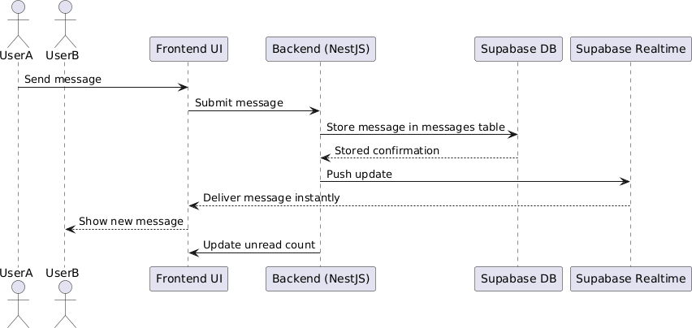

Figure 4.14 Messaging and Notification Module

When a user sends a message, the backend persists it in the messages table within Supabase. The conversation state is updated accordingly. Using Supabase Realtime functionality, the message is instantly delivered to the recipient. Additionally, the system updates unread message counts and triggers notifications within the user interface.

Portfolio Management Module
This sequence illustrates portfolio creation and management for freelancers.
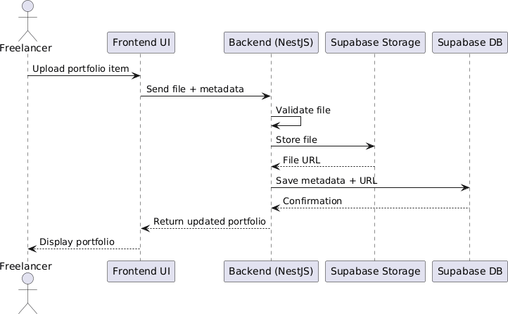

Figure 4.15 Portfolio Management Module

A freelancer uploads portfolio items through the application interface. The system validates the uploaded files and stores them securely in Supabase Storage. Associated metadata is recorded in the database. The updated portfolio information is then retrieved and displayed on the user’s dashboard.

Class Diagram
The class diagram of the OutSauce system provides a comprehensive structural representation of the platform by illustrating its major classes, service components, enumerations, and their interrelationships. It demonstrates how core functionalities such as authentication, lead generation, subscriptions, networking, messaging, and AI-powered content creation are organized within a modular and scalable architecture.

The diagram reflects a service-oriented design in which responsibilities are distributed across models (data entities), services (business logic), components (interaction layer), and external engines. This layered separation improves maintainability, reusability, and future scalability of the platform.
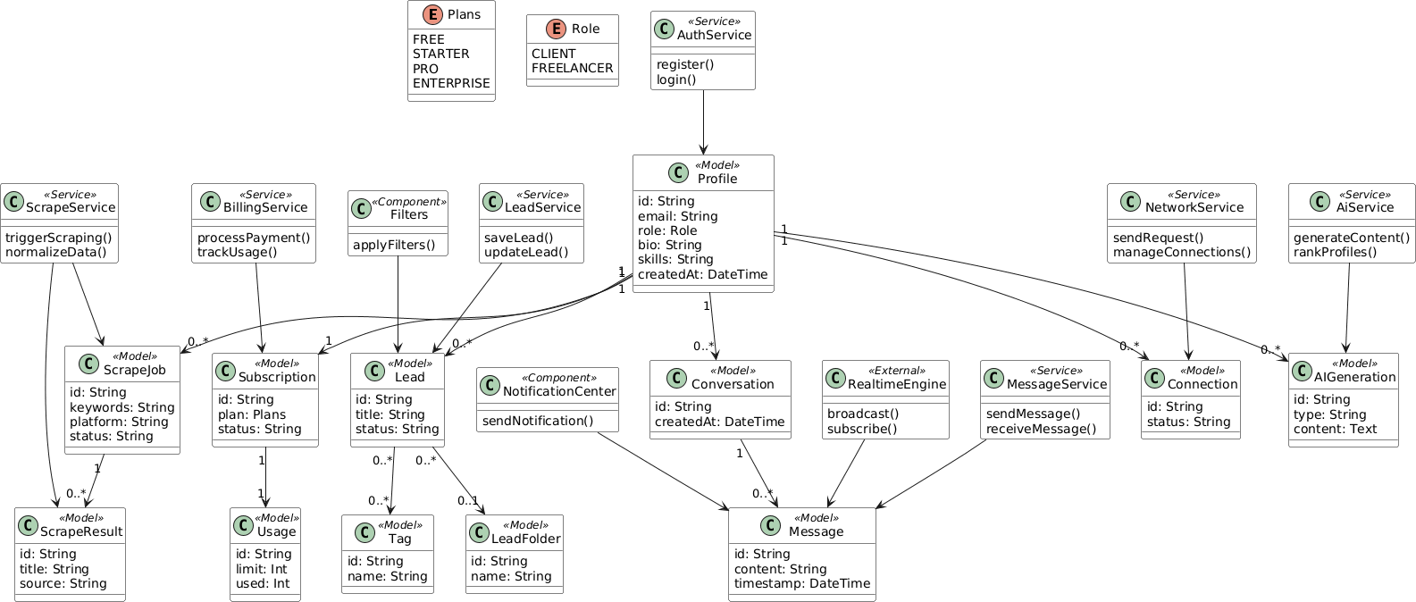
Figure 4.16 Class Diagram

Core Models (Entity Layer)

The model layer contains the primary data entities that store and manage system information. These classes represent the essential business objects of the OutSauce platform.

  - Profile: Central user profile containing user identity, email, role, biography, skills, and account creation date.
  - Lead: Stores potential business opportunities with title and status details.
  - LeadFolder: Organizes leads into custom collections for better management.
  - Tag: Enables classification and filtering of leads using labels.
  - Subscription: Maintains plan information and subscription status.
  - Usage: Tracks feature limits and consumed usage under subscription plans.
  - ScrapeJob: Represents automated scraping tasks containing keywords, source platform, and status.
  - ScrapeResult: Stores collected data such as titles and source information from scraping operations.
  - Connection: Represents networking relationships between platform users.
  - Conversation: Stores chat sessions between connected users.
  - Message: Contains message content and timestamps within conversations.
  - AIGeneration: Stores AI-generated outputs such as proposals, ranked profiles, or written content.

Key Relationships
  - One Profile can own multiple Leads, Subscriptions, Connections, and Conversations.
  - One Lead can contain multiple Tags and belong to multiple LeadFolders.
  - One Conversation contains multiple Messages.
  - One Subscription is associated with one Usage record.
  - One ScrapeJob can generate multiple ScrapeResults.

These entities collectively support lead management, communication, automation, and monetization features of the platform.

Service Layer (Business Logic)

The service layer manages application workflows and business operations. These classes process user requests and interact with the model layer.

  - AuthService: Handles user registration and login functionality.

  - ScrapeService: Triggers scraping processes and normalizes extracted data.
  - BillingService: Processes subscription payments and monitors usage.
  - LeadService: Creates, saves, and updates lead records.
  - NetworkService: Sends networking requests and manages user connections.
  - MessageService: Sends and receives user messages.
  - AIService: Generates AI content and ranks user profiles.

Responsibilities of Service Layer

  - Applying business rules and validation
  - Coordinating workflows between modules
  - Processing user requests efficiently
  - Managing system automation and integrations

This layer ensures separation between raw data storage and operational logic.

Components (Interaction Layer)

The component layer contains interface-supporting modules that enhance user interaction and system usability.

  - Filters: Applies search and filtering criteria to leads and platform records.
  - NotificationCenter: Sends notifications and alerts to users regarding updates, messages, or activities.

These components improve the responsiveness and usability of the OutSauce platform.

Enumerations

The system also defines reusable enumerated types for consistency.

  - Plans: FREE, STARTER, PRO, ENTERPRISE
  - Role: CLIENT, FREELANCER

These enums standardize user roles and subscription categories throughout the application.

External Integrations

The diagram includes external engines and third-party processing modules for real-time and intelligent features.

  - RealtimeEngine: Supports live broadcasting and subscription-based real-time communication.
  - AIService: Provides intelligent content generation and profile ranking.

These integrations enable modern platform capabilities such as live messaging and AI automation.

Architectural Overview

Overall, the class diagram demonstrates a robust and scalable architecture based on clear separation of concerns:

  - Model Layer manages structured data entities
  - Service Layer handles business logic and workflows
  - Component Layer improves user interaction
  - External Systems enable real-time and AI-powered operations

This architecture allows the OutSauce platform to efficiently support complex processes such as automated lead scraping, subscription management, freelancer-client networking, real- time messaging, and intelligent content generation in a maintainable and extensible manner.

Chapter 5 Implementation

Implementation
Implementation is the phase in which the system design is translated into a fully functional and operational application. In OutSauce, this phase is driven by modular backend services, AI-powered automation workflows, and third-party integrations that collectively transform unstructured multi-platform data into structured, meaningful, and actionable insights.

The system is built on a modern SaaS architecture using Supabase (PostgreSQL, Authentication, and Realtime services) as the core backend infrastructure. n8n is used for workflow automation and data scraping pipelines, while Anthropic API is integrated for advanced AI-based content generation. The frontend is developed using Next.js (App Router) along with ShadCN UI, ensuring a responsive, scalable, and consistent user interface across all modules including scraping, lead management, messaging, AI tools, billing, and system settings.

Algorithm

The OutSauce system is built on a set of modular algorithms that handle scraping, lead management, AI processing, communication, and system automation. These algorithms work together to convert raw data into structured, actionable insights.

Multiplatform Scraping and Aggregation Algorithm
This algorithm is responsible for collecting and consolidating data from multiple external platforms into a unified structure.

Input:
Keywords, filters (skills, location, salary range, experience level, and platform selection)

Process:
- Trigger scraping workflows using n8n automation engine
- Extract data from platforms such as LinkedIn, Upwork, Fiverr, and Reddit
- Normalize heterogeneous data into a unified schema

- Validate required attributes and remove incomplete records
- Store structured output in Supabase ScrapeResults table

Output:
A structured dataset of job opportunities and freelance listings stored in the database.

Lead Management Algorithm
This algorithm converts raw scraped data into actionable business leads.

Input:
Selected scrape results

Process:
- Insert selected records into the Leads table
- Assign default status (New, Contacted, In Progress, Closed)
- Organize leads into user-defined folders
- Apply tags for categorization and filtering
- Enable bulk operations such as export (CSV, JSON, PDF)

Output:
A structured and manageable lead pipeline for users.

AI-Based Ranking and Matching Algorithm

This algorithm ranks opportunities based on user preferences and relevance scoring.

Input:
User-defined filters and scraped dataset

Process:
- Retrieve relevant records from Supabase
- Match user skills, preferences, and experience with opportunities
- Apply AI-based scoring logic for relevance estimation

- Enhance ranking using market demand and trend signals
- Sort results based on computed relevance score

Output:
A ranked list of job opportunities or freelancer profiles.

AI Content Generation (Anthropic Integration)
This algorithm generates professional content using AI capabilities.

Input:
User profile data and selected content template

Process:

- Construct structured prompt based on user input
- Send request to Anthropic API
- Generate professional outputs such as:
- Bio
- Resume
- Cover Letter
- Gig Description
- Profile Summary
- Store generated content in AIGeneration table

Output:
AI-generated professional documents tailored to user needs.

Messaging System Algorithm

This algorithm manages real-time communication between users.

Input:
Sender ID, receiver ID, and message content

Process:
- Validate user authentication via Supabase Auth
- Store message in Messages table
- Maintain structured conversation threads
- Trigger real-time updates using Supabase Realtime

Output:
A fully functional real-time messaging system.

Notification System Algorithm

This algorithm provides real-time system alerts and updates.

Input:
System-generated events (messages, scraping updates, AI outputs)

Process:
- Capture events from backend modules
- Store notification logs in database
- Push real-time updates using Supabase Realtime
- Update user interface instantly

Output:
Live notifications delivered to users in real time.

Portfolio Management Algorithm

This algorithm manages user portfolios and professional profiles.

Input:
Portfolio details including title, description, and media files

Process:
- Upload media files to Supabase Storage
- Store portfolio metadata in database

- Link portfolio entries to user profiles
- Enable retrieval and display in user dashboard

Output:
A structured and dynamically managed professional portfolio system.

Billing and Subscription Management Algorithm
This algorithm enforces plan-based access control and usage tracking.

Input:
User subscription activity and system usage logs

Process:
- Track system usage (scrapes, leads, AI generations)
- Enforce limits based on subscription plans (Free, Starter, Pro, Enterprise)
- Integrate Stripe for payment processing and subscription handling
- Update usage and billing records in database

Output:
A controlled and tier-based access system ensuring fair resource usage.

Network and Lead Discovery

This algorithm enables intelligent user and opportunity matching.

Input:
User skills, interests, and profile data

Process:
- Match users based on similarity in skills and preferences
- Recommend relevant professional connections
- Identify potential leads and opportunities
- Compute compatibility score using matching logic

Output:
Personalized recommendations for connections and opportunities.

External APIs and Tools
OutSauce integrates multiple external APIs and third-party tools to support its core functionalities, including data scraping, workflow automation, authentication, AI-based processing, and payment management. These integrations enable a scalable, modular, and service-oriented system architecture by delegating specialized tasks to reliable external services.
Table 5.1 External APIs and Tools used in OutSauce: This table briefly presents the external APIs and tools used in OutSauce, highlighting their purposes and contributions to the platform’s functionality.

Tool /  API | Purpose | Key Functionality
n8n | Scraping & Workflow Automation Engine | Orchestrates automated workflows triggered via webhooks. Collects job and freelancer data from platforms such as LinkedIn, Upwork, Fiverr, and Reddit. Performs data cleaning, deduplication, normalization, and forwards  structured results to backend APIs.
Supabase | Backend-as-a- Service | Provides PostgreSQL database, authentication (email and OAuth), real-time subscriptions, Row-Level Security (RLS), and file storage for managing user data and  portfolios.
Next.js (App Router) | Frontend Framework | Used to build the user interface including dashboard, scraping module, leads management, messaging, AI tools, billing, and settings with server-side rendering and modern  routing capabilities.
NestJS | Backend API Framework | Handles RESTful APIs, business logic implementation, modular architecture, and integration with external services. It also validates authentication using Supabase JWT  tokens.
Anthropic API  (LLM) | AI Content Generation | Generates professional content such as resumes, cover letters, bios, gig descriptions, and profile summaries using  structured prompts and contextual user data.
Stripe | Payment Gateway | Manages subscription plans (Free, Starter, Pro, Enterprise), handles billing, checkout sessions, and provides a secure  customer billing portal.
Tailwind CSS + ShadCN  UI | UI Design System | Provides reusable, responsive, and accessible UI compo-nents, ensuring consistent design across the platform.
GitHub | Version Control System | Used for source code management, team collaboration, and CI/CD workflow integration.

User Interface
The OutSauce user interface is designed using a modern, modular, and dashboard-driven architecture, built with Next.js and ShadCN UI. The design prioritizes usability, clarity, responsiveness, and consistency across all system modules.

Landing and Authentication Interface
The landing page serves as the entry point of the platform, presenting OutSauce as an all-in- one solution for freelancers, job seekers, and clients. It includes clear navigation for SignIn and SignUp actions.

Authentication is handled through Supabase and supports both email/password and OAuth- based login. Middleware ensures secure session management and automatic redirection to the dashboard upon successful authentication.

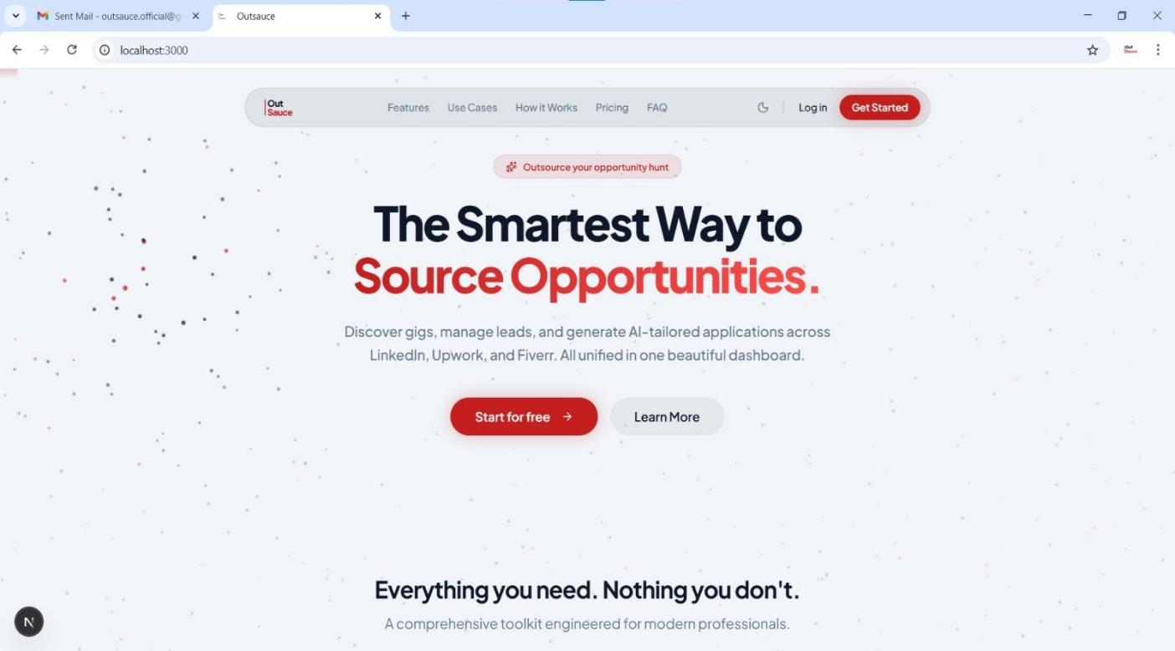

Figure 5.1 Landing Interface

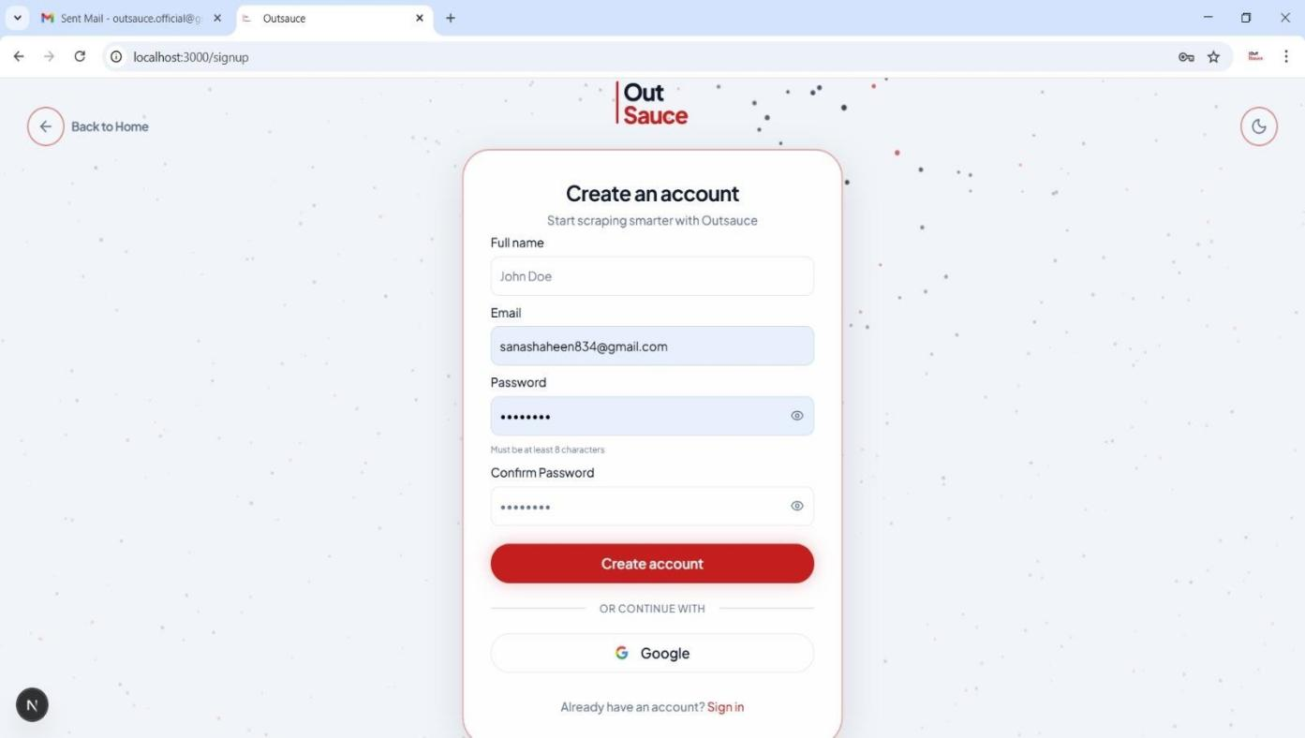

Figure 5.2 Authentication SignUP Interface

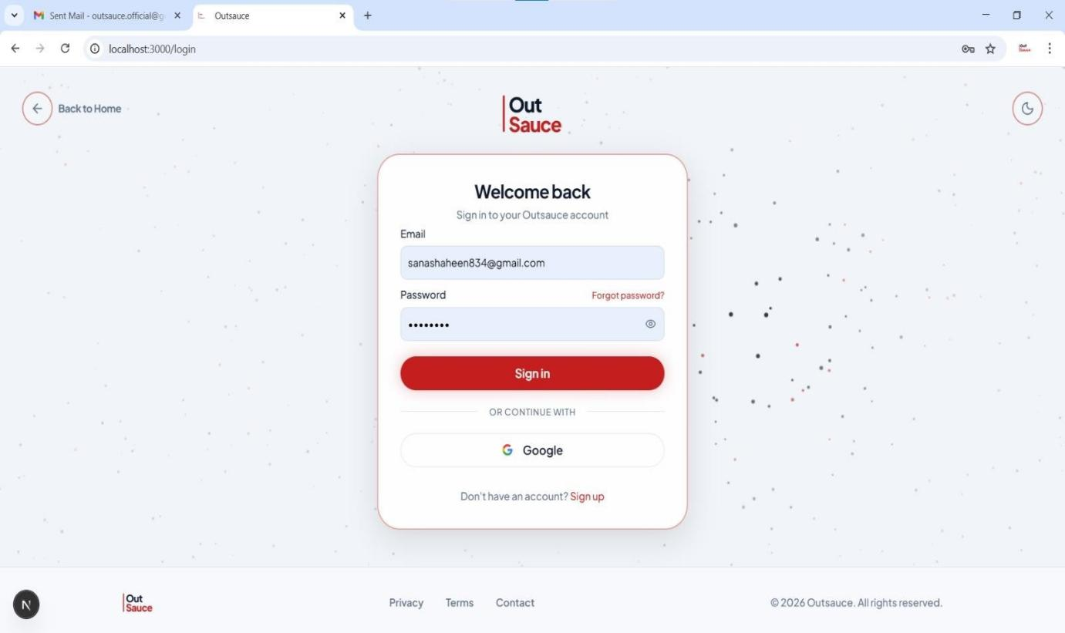
Figure 5.3 Authentication SignIn Interface

Dashboard Module

The dashboard acts as the central control panel of the system. It provides a consolidated view of system activity and user performance.

Key elements include:

- Scrape job status overview
- Lead pipeline summary (New, Contacted, In Progress, Closed)
- AI generation usage tracking
- Subscription and billing status

It also provides quick navigation to major modules such as Scrapes, Leads, Messages, AI Tools, Billing, and Settings.
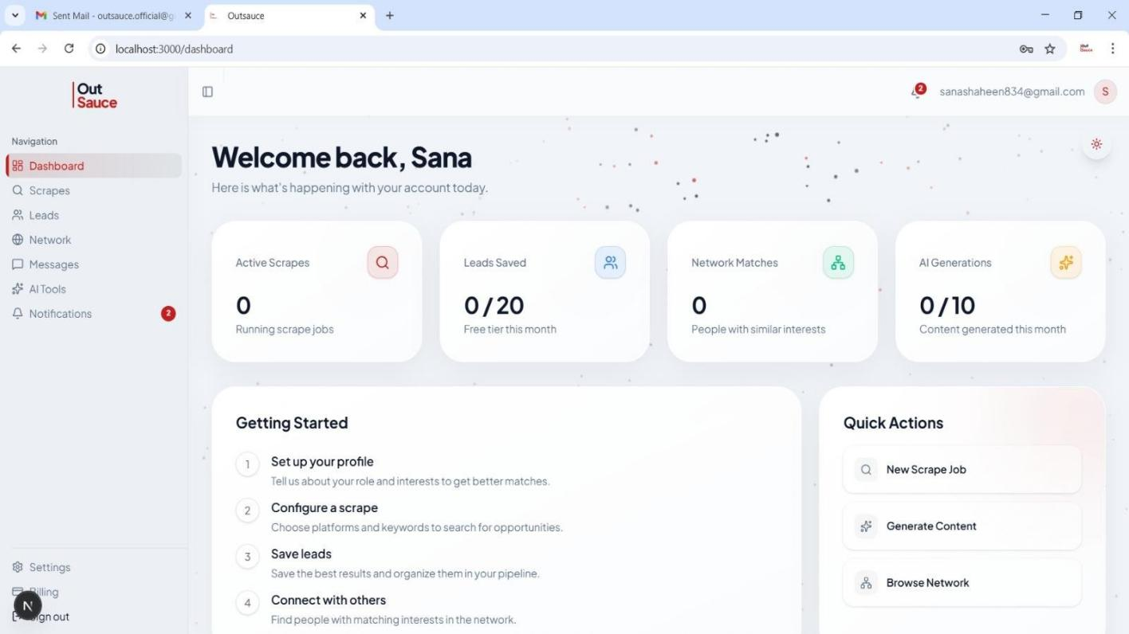

Figure 5.4 Dashboard Interface

Scrapes Module Interface
This module allows users to configure and manage scraping jobs. Functionalities include:
- Creating scrape jobs with filters (skills, location, salary, platform, remote preference)
- Monitoring real-time scraping progress using Supabase Realtime
- Viewing structured scrape results in tabular format
- Converting scrape results into leads
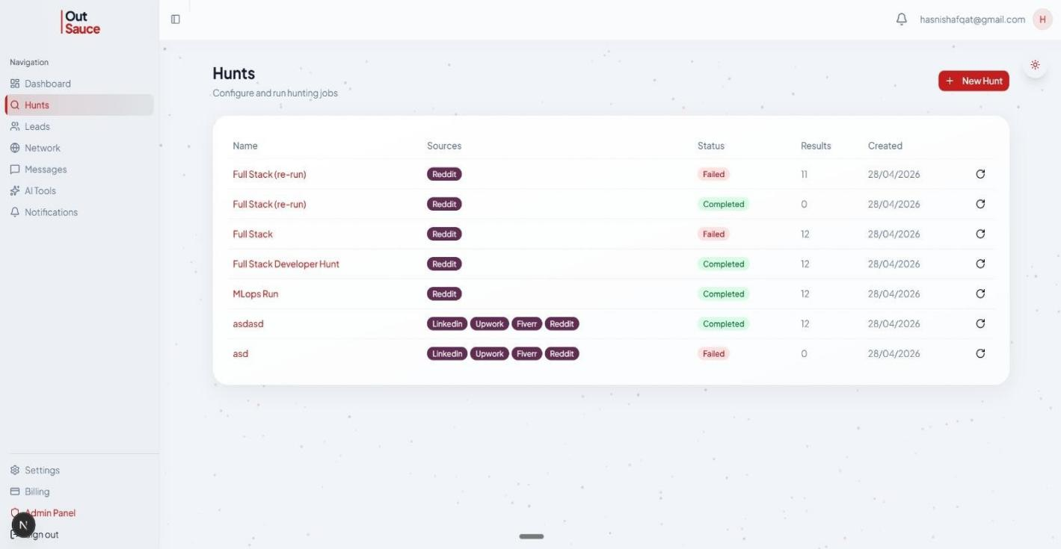

Figure 5.5 Scrape Module Interface

Leads Module Interface
The leads system provides structured pipeline management for collected data. Key features include:
- Lead status tracking (New, Contacted, In Progress, Closed, Archived)
- Folder-based organization system
- Tagging for advanced filtering
- Bulk lead saving from scrape results
- Export functionality (CSV, JSON, and PDF formats)
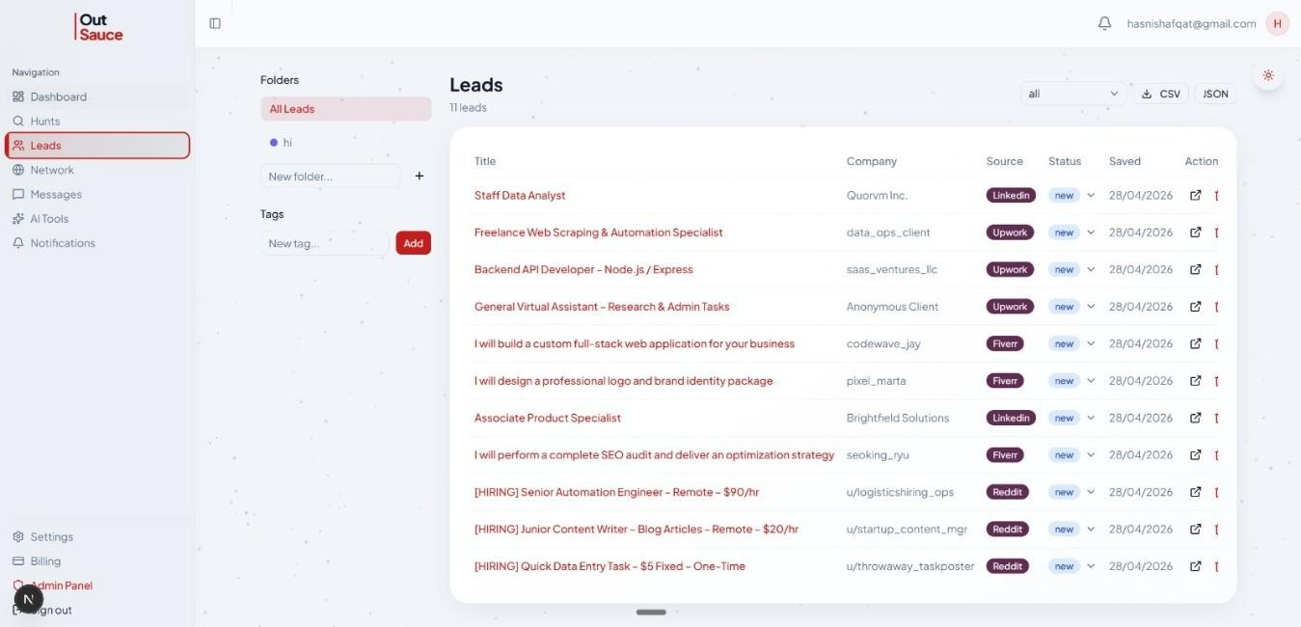

Figure 5.6 Lead Module Interface

Messaging Module Interface
The messaging system enables real-time communication between users. Features include:
- Conversation-based chat interface
- Real-time message updates
- Read/unread status indicators
- Notification badges for new messages
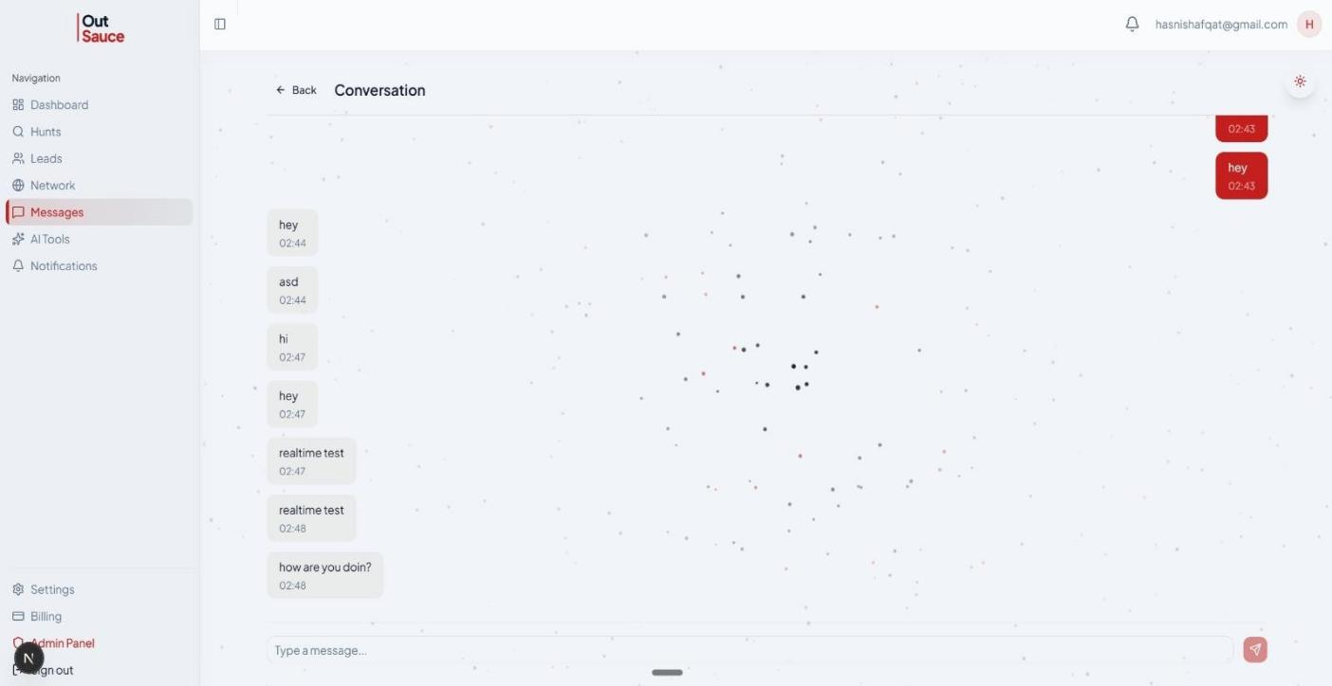

Figure 5.7 Messaging Module Interface

Network Module Interface
This module supports user discovery and professional networking. It includes:
- Skill-based user matching system
- Connection request management (send, accept, reject)
- Compatibility-based suggestions
- User profile previews
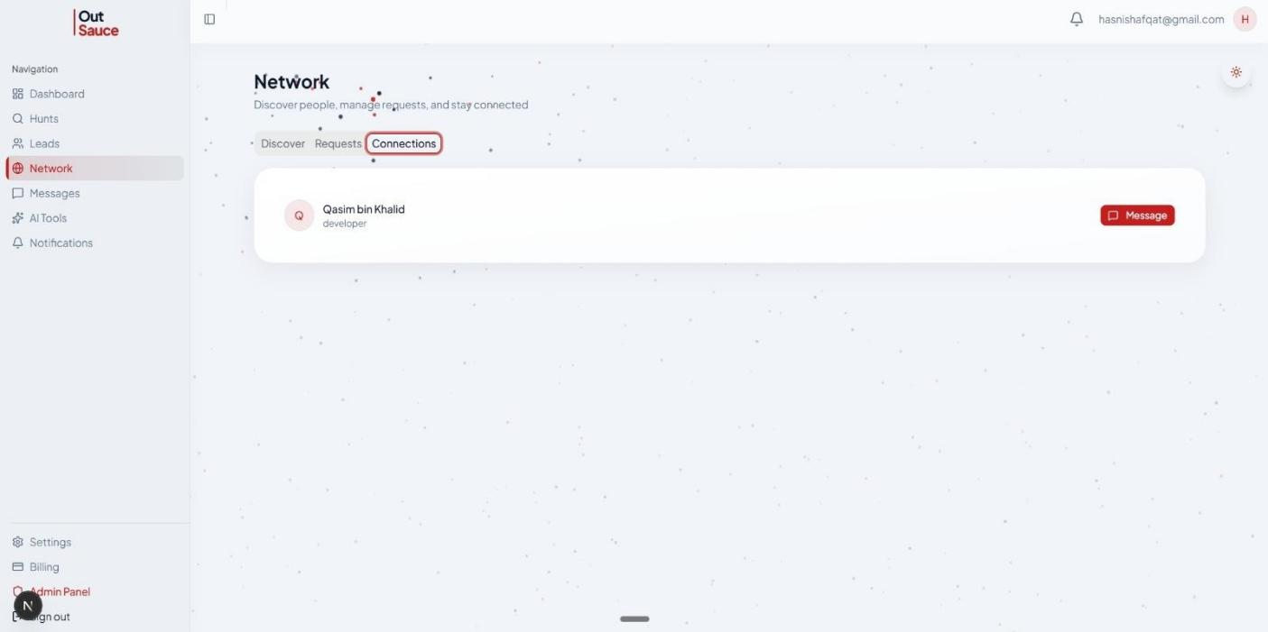

Figure 5.8 Network Module Interface

AI Tools Module Interface
The AI tools module enables automated content generation. Users can generate:
- Professional bios
- Resumes
- Cover letters
- Gig descriptions
- Profile summaries

All generated content is stored in history and managed under usage limits.
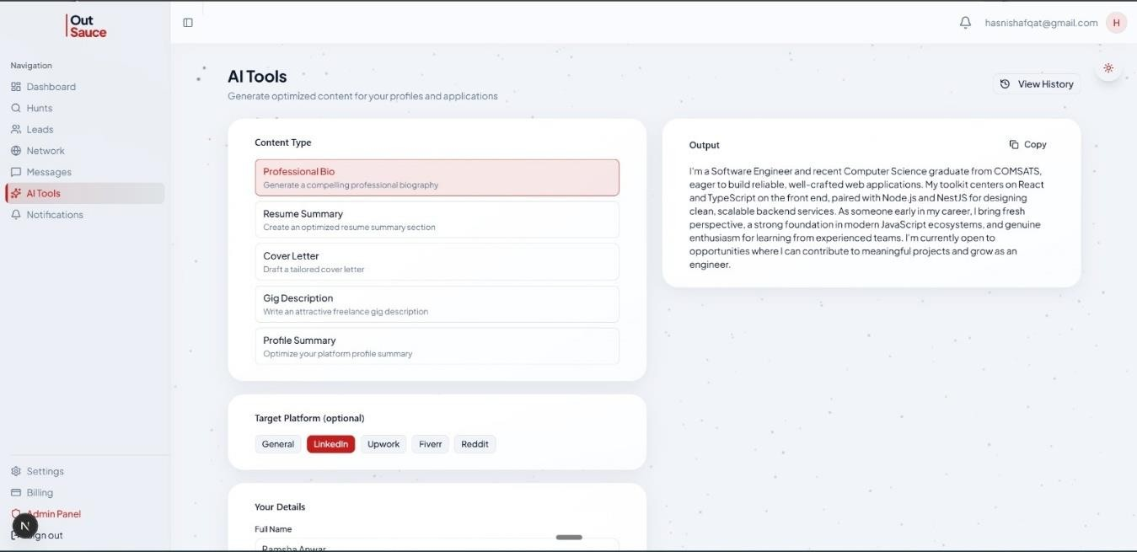

Figure 5.9 AI Module Interface

Billing Module Interface
This module manages subscription and payment functionality. It includes:
- Plan selection (Free, Starter, Pro, Enterprise)
- Usage tracking for scrapes, leads, and AI generation
- Stripe checkout integration
- Customer billing portal access
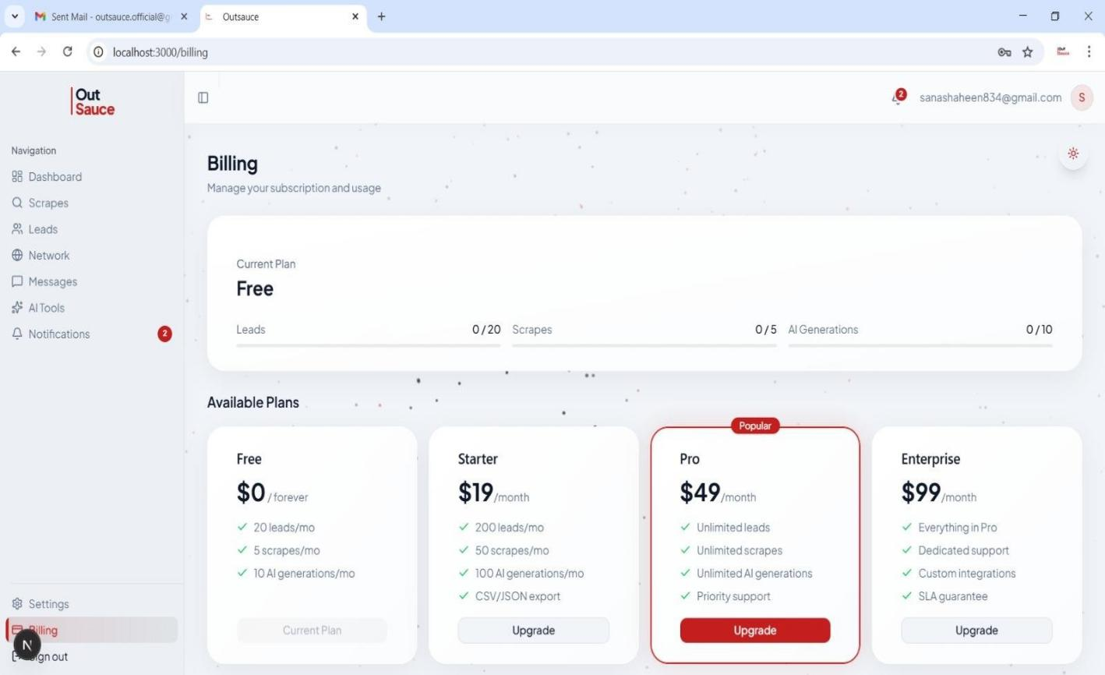

Figure 5.10 Billing Module Interface

Settings Module Interface
The settings interface allows users to manage their account configuration. Features include:
- Profile management
- Skills and interests update
- Notification preferences
- Security settings
- Linked accounts
- Discoverability options

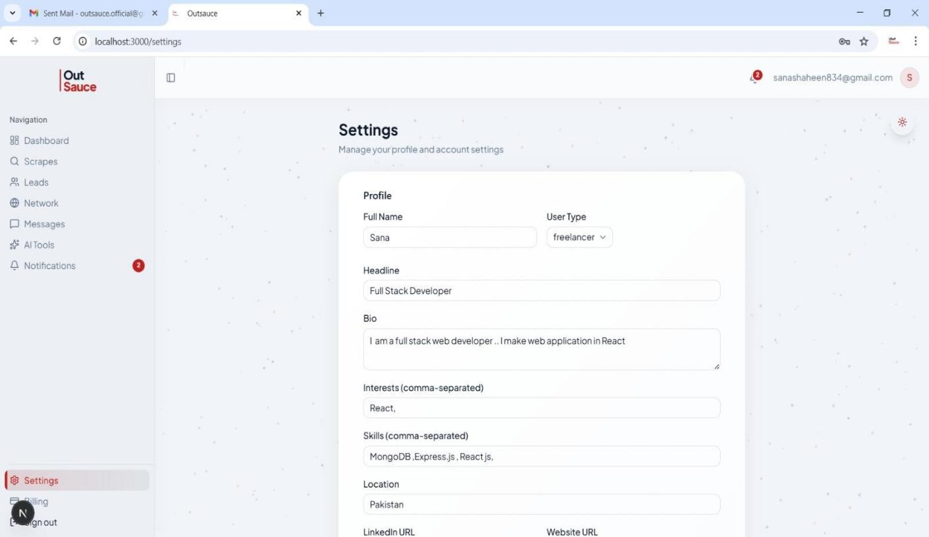

Figure 5.11 Setting Module Interface

Chapter 6 Testing and Evaluation

Testing And Evaluation
The OutSauce platform was evaluated to ensure that all system components function correctly, meet the defined requirements, and perform reliably under expected operational conditions. Testing was conducted using a combination of manual testing techniques and automated test suites, covering functional correctness, integration reliability, performance benchmarks, and system stability.

Manual testing focused on validating end-to-end workflows and module-level behavior, while automated testing ensured regression safety and continuous quality assurance throughout the development lifecycle using CI/CD pipelines.

Manual Testing
Manual testing was performed across four key levels: system testing, unit testing, functional testing, and integration testing. These tests ensured that individual components and the complete system behave as expected.

System Testing
System testing validates the complete OutSauce platform as an integrated system, ensuring that all modules work together seamlessly. The testing covered the full workflow from authentication to AI- driven lead generation and communication.
Table 6.1 Key System Test Scenarios: This table briefly presents the key system testing scenarios performed to validate the overall functionality of OutSauce.
Test ID | Test Scenario | Expected Result | Status
ST-01 | User registration and login flow | User successfully registered, authenticated, and redirected to dashboard | Pass
ST-02 | Freelancer data aggregation pipeline (n8n workflow) | Freelancer profiles scraped, normalized, and stored in database | Pass
ST-03 | AI-based lead generation execution | Ranked lead list generated within 5 seconds | Pass
ST-04 | Client project posting workflow | Project successfully created and visible to relevant freelancers | Pass
ST-05 | End-to-end proposal generation | AI-generated proposal created and stored successfully | Pass
ST-06 | Messaging system between client and freelancer | Message delivered and conversation updated in real-time | Pass
ST-07 | Admin user management operations | Admin can add/remove users with proper confirmation | Pass

Unit Testing
Unit testing was performed on individual services and functions in isolation to ensure correctness at the component level. The tests primarily focused on authentication, ranking logic, and AI-based proposal generation modules. Each function was tested with both valid and invalid inputs to verify expected behavior and error handling. This approach helped identify issues early in development and ensured the reliability and stability of critical system components.
Table 6.2 Unit Testing: Authentication Module: This table briefly presents the unit tests conducted on the authentication module.
Test ID | Function | Input | Expected Output | Status
UT-01 | AuthService.register() | Valid user data | User created and session initiated | Pass
UT-02 | AuthService.register() | Duplicate email | Error: Email already exists | Pass
UT-03 | AuthService.login() | Valid credentials | Authentication token  generated | Pass
UT-04 | AuthService.login() | Invalid credentials | Error: Invalid login | Pass
UT-05 | Password validation | Weak password | Validation error triggered | Pass

Table 6.3 Unit Testing: Ranking Engine: This table briefly presents the unit tests conducted on the rank-
ing engine.

Test ID | Function | Input | Expected  Output | Status
UT-06 | RankingEngine.calculateScore() | Freelancer profile + filters | Score (0–100)  generated | Pass
UT-07 | RankingEngine.analyzeSkills() | Skills vs job requirements | Match percentage  returned | Pass
UT-08 | RankingEngine.storeRankings() | Computed ranking data | Stored in database  successfully | Pass

Table 6.4 Unit Testing: Proposal Generation: This table briefly presents the unit tests conducted on the proposal generation module.

Test ID | Function | Input | Expected  Output | Status
UT-09 | ProposalService.generate() | Freelancer + project details | AI-  generated proposal text | Pass
UT-10 | ProposalService.save() | Proposal object | Stored in  database | Pass

Functional Testing
Functional testing ensures that each feature of OutSauce operates according to the defined functional requirements and business logic.

Table 6.5 Functional Testing Core Features: This table briefly presents the functional tests performed on the core features of OutSauce.

Test ID | Feature | Scenario | Expected Behavior | Status
FT-01 | User Registration | Create account with valid data | Account created successfully | Pass
FT-02 | Authentication | Login with invalid credentials | Access denied with error message | Pass
FT-03 | Profile Management | Update skills and bio | Profile updated and reflected in AI system | Pass
FT-04 | AI Lead  Generation | Generate leads using  complete profile | Ranked leads displayed  within 5 seconds | Pass
FT-05 | Project Posting | Missing required  fields | Validation error shown | Pass
FT-06 | Messaging  System | Send message  between users | Message delivered  successfully | Pass
FT-07 | Admin Panel | Remove active user | Confirmation req-uired before deletion | Pass

Integration Testing
Integration testing was performed to verify communication between system modules and ensure smooth data flow across services such as scraping, AI processing, database storage, and messaging.

Table 6.6 Integration Testing: System Module: This table briefly presents the integration tests performed
to verify interactions between system modules.

Test ID | Modules Tested | Scenario | Expected Behavior | Status
IT-01 | n8n → Database | Scraped freelancer data ingestion | Data stored in structured format | Pass
IT-02 | Ranking Engine → Database | AI scoring execution | Rankings stored with correct mapping | Pass
IT-03 | AI Service →  Proposal Engine → DB | Proposal generation workflow | Proposal generated and saved | Pass
IT-04 | Messaging → Notification Service | Message sent event trigger | Real-time notification delivered | Pass
IT-05 | Auth → Profile → Lead System | Full user workflow execution | Seamless execution without errors | Pass

Automated Testing
Automated testing was implemented to ensure continuous validation of system behavior and to prevent regression issues during ongoing development. All tests are executed through a CI/CD pipeline using GitHub Actions on every commit and pull request.

Table 6.7 Automated Testing Tools: This table briefly presents the automated testing tools used for conti-nuous testing and quality assurance.

Tool | Purpose
Jest | Unit and integration testing for backend services
GitHub Actions | CI/CD automation and running tests on every push/pull request

Automated Test Coverage
The automated test suite covers the following critical system areas:

- User authentication (registration, login, session validation)
- Freelancer ranking engine accuracy and consistency
- AI-based proposal generation output validation
- REST API endpoint response validation
- Database CRUD operation integrity
- End-to-end workflow validation (registration → scraping → ranking → proposal generation)

Chapter 7 Conclusion and Future Work

Conclusion And Future Work
OutSauce was developed to address a key limitation in the freelancing ecosystem: the fragmentation of talent across multiple platforms such as Upwork, Fiverr, LinkedIn, and Reddit. By integrating freelancer data from multiple sources and applying AI-driven ranking and automated proposal generation, the system provides a more efficient and intelligent way for clients to discover freelancers and for freelancers to find relevant opportunities.

The platform successfully implements core features including user authentication, profile management, AI-based lead generation, project posting, messaging, and administrative control. Its modular architecture using Next.js, NestJS, and Supabase ensures scalability, maintainability, and performance. Overall, OutSauce demonstrates a practical and effective solution for improving freelancer discovery through automation and AI.

Conclusion
OutSauce has been successfully designed and implemented as an AI-powered freelancer lead generation platform that improves upon traditional freelancing systems by centralizing data and automating key processes.

The system fulfills all major functional requirements:

- User Registration and Authentication
- Profile Management
- AI-Based Lead Generation
- Project Posting by Clients
- Messaging System
- Admin Management Panel

It also addresses key non-functional requirements including performance, scalability, security, reliability, and usability.

The integration of n8n enables automated data aggregation, while AI-based ranking and proposal generation enhance decision-making and productivity for users. The use of a

modular full-stack architecture ensures that the system is scalable and maintainable for future expansion.

In conclusion, OutSauce provides a modern, intelligent, and scalable solution that improves freelancer discovery and enhances overall efficiency in the freelancing ecosystem.

Future Work
Although the current implementation of OutSauce provides a robust and scalable platform for multi-platform data aggregation, lead management, networking, and AI-powered content generation, there are several areas where the system can be further enhanced to improve functionality, performance, and user experience.

Advanced Payment and Transaction Ecosystem

While subscription-based billing has already been successfully implemented using Stripe, future enhancements can extend this functionality to support full transactional capabilities within the platform. This includes enabling direct client-to-freelancer payments, milestone-based contracts, escrow systems, and automated invoice generation. Such improvements will transform OutSauce into a complete end-to-end freelancing marketplace.

Expansion of Platform Integrations

Currently, the system aggregates data from major platforms such as LinkedIn, Upwork, Fiverr, and Reddit. Future development can extend integration support to additional freelancing platforms such as Freelancer.com, Guru, and PeoplePerHour. This will significantly increase data coverage, improve opportunity discovery, and enhance the system’s value for users by providing a more comprehensive aggregation ecosystem.

Enhancement of AI Capabilities

The current AI functionalities can be further improved by incorporating advanced techniques such as fine-tuning large language models, implementing Retrieval-

Augmented Generation (RAG), and integrating context-aware recommendation systems. These enhancements will enable more accurate ranking, personalized suggestions, and higher-quality AI-generated content, thereby improving decision- making and productivity for users.

Mobile Application Development

To improve accessibility and user engagement, dedicated mobile applications for Android and iOS platforms can be developed. A mobile version of OutSauce will provide real-time notifications, seamless communication, and on-the-go access to scraping results, leads, and messaging features, significantly enhancing the overall user experience.

CRM Integration for Enterprise Users

Future versions of OutSauce can include integration with popular Customer Relationship Management (CRM) systems such as HubSpot and Salesforce. This will enable enterprise users to synchronize leads, track interactions, and manage client relationships more effectively, bridging the gap between lead generation and customer management.

Multi-Language and Localization Support

Introducing multi-language support will allow the platform to cater to a global audience. Localization features, including region-based content customization and language-specific AI generation, will improve usability and accessibility for non- English-speaking users.

Freelancer Verification and Trust System

A robust verification mechanism can be implemented to enhance platform credibility. This may include AI-based portfolio analysis, skill validation tests, and integration with third-party verification services. Such a system will improve trust among users and ensure higher-quality interactions between clients and freelancers.

Advanced Analytics and Business Intelligence

The analytics module can be further enhanced by incorporating advanced reporting tools, Key Performance Indicators (KPIs), predictive analytics, and market trend analysis. These features will provide deeper insights into user activity, lead conversion rates, and platform performance, supporting data-driven decision-making.

Intelligent Recommendation System

Future improvements can include machine learning-based recommendation systems that suggest relevant leads, connections, and opportunities based on user behavior, preferences, and historical interactions. This will increase user engagement and improve matching accuracy.

Scalability and Performance Optimization

As the platform grows, further optimization techniques such as distributed processing, caching strategies, and microservices architecture can be implemented to ensure high performance, scalability, and reliability under increased load.

References
- Supabase Inc., “Supabase Documentation: Authentication, PostgreSQL, Realtime, and Row Level Security,” 2025. [Online]. Available: https://supabase.com/docs

- Vercel, “Next.js Documentation – The React Framework for the Web (App Router),” 2025. [Online]. Available: https://nextjs.org/docs

- NestJS, “NestJS Documentation – Progressive Node.js Framework,” 2025. [Online]. Available: https://docs.nestjs.com

- n8n, “n8n Documentation – Workflow Automation,” 2025. [Online]. Available: https://docs.n8n.io

- Reddit, “Reddit API Documentation,” 2025. [Online]. Available: https://www.reddit.com/dev/api

- Anthropic, “Anthropic API Documentation and Prompt Engineering Guide,” 2025. [Online]. Available: https://docs.anthropic.com

- Stripe, “Stripe Documentation – Payments and Billing,” 2025. [Online]. Available: https://docs.stripe.com

- K. Schwaber and J. Sutherland, “The Scrum Guide,” Scrum.org, Nov. 2020. [Online]. Available: https://scrumguides.org/scrum-guide.html

- C. Larman, Agile and Iterative Development: A Manager’s Guide. Boston, MA, USA: Addison-Wesley, 2004.

- I. Sommerville, Software Engineering, 10th ed. Boston, MA, USA: Pearson, 2016.

- Upwork, “Upwork Developer Platform Guidelines,” 2025. [Online]. Available: https://developers.upwork.com

- Fiverr, “Fiverr Help Center – Gig and Profile Structure,” 2025. [Online]. Available: https://help.fiverr.com

- LinkedIn, “LinkedIn Developer Platform Documentation,” 2025. [Online]. Available: https://developer.linkedin.com

- Gartner, “Market Guide for AI-Powered Talent Acquisition Technologies,” Gartner Research, 2023.

- Tailwind Labs, “Tailwind CSS Documentation,” 2025. [Online]. Available: https://tailwindcss.com/docs

- shadcn, “shadcn/ui Component Library Documentation,” 2025. [Online]. Available: https://ui.shadcn.com

- Popereshnyak, S., Chornobryvets, D., & Bakaiev, O. (2025). AI-Driven Intelligent Platform for Freelance Services Management and Monitoring. CEUR Workshop Proceedings, Vol. 4053. https://ceur-ws.org/Vol-4053/paper12.pdf

- Demirci, O., Hannane, J., & Zhu, X. (2025). Who Is AI Replacing? The Impact of Generative AI on Online Freelancing Platforms. Management Science, 71(10), 8097–8108. https://pubsonline.informs.org/doi/10.1287/mnsc.2024.05420

- Soni, V. K. (2025). Freelancing Platforms: Revolutionizing The Gig Economy.
Atlantis Press. https://www.atlantis-press.com/article/126012642.pdf

- Sarang-Sieminski, A., & Christianson, R. (n.d.). Agile/Scrum for Capstone Project Management. Capstone Design Community. http://capstonedesigncommunity.org/sites/default/files/proceedings_papers/0048_0.pdf

